CLASS : XII
SUBJECT : mathematics CHAPTER: 2 inverse trigonometry
DATE OF GIVING: DATE OF SUBMISSION:
Sr. No. | Knowledge Based | Marks | Date
K-1 | 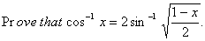  = 2$\cos^{-1}{\sqrt{\frac{1+x}{2}}}$ | 4
K2 | Find the principal value of $\cos^{-1}{\cos{\frac{2π}{3}}}$ +$\sin^{-1}{\sin{\frac{2π}{3}}}$ | 1
K-3 | Prove that $\tan^{-1}{1/2}$ + $\tan^{-1}{1/5}$ + $\tan^{-1}{1/8}$ = $\frac{π}{4}$ | 4
K-4 | - 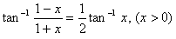  - 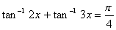  - 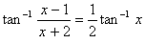 | 4
K-5 | Prove: sin⁻¹ 1/$\sqrt{5}$ +cot⁻¹ 3 =π/4 | 1
K-6 | tan⁻¹ $\frac{x+1}{x-1}$ +tan⁻¹ $\frac{x-1}{x}$ =2π/3 solve for x | 4
S. No. | Understanding Based
U-1 | 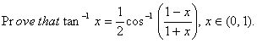 | 1
U-2 |  | 1
U-3 | . Find the Value of  - 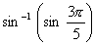  - 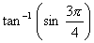 | 4
U-4 | 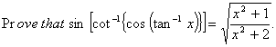 | 4
U-5 | If cos⁻¹ a+ cos⁻¹ b+ cos⁻¹ c=π ,prove that a² + b² + c²+ 2abc=1 | 4
U6 | Find the value of x  $\tan^{-1}{\frac{x-1}{x+1}}$ + $\tan^{-1}{\frac{2x-1}{2x+1}}$ =$\tan^{-1}{\frac{23}{36}}$ | 4
S. No. | Application
A-1 | Show that $\tan^{-1}{\frac{\sqrt{1+x^{2}}+\sqrt{1-x^{2}}}{\sqrt{1+x^{2}}-\sqrt{1-x^{2}}}}$ = $\frac{π}{4}$ + ½ $\cos^{-1}{x^{2}}$ | 4
A-2 |  | 4
A-3 | Solve for x : cot⁻¹ x – cot⁻¹ (x+2) = π/3 | 4
A-4 | Find three branches , other than the principal value branch of $\tan^{-1}{x}$ | 1
S.No. | HOTS
H-1 | Prove that $\cot^{-1}{\frac{ab+1}{a-b}}$ + $\cot^{-1}{\frac{bc+1}{b-c}}$ + $\cot^{-1}{\frac{ca+1}{c-a}}$ =0 | 4
H-2 | Show that  - 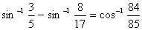  - 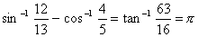  - 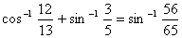  - 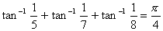  - 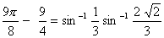  - 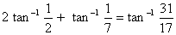 | 4 each part
H-3 |  | 6
H4 | Prove that $\tan^{-1}{\sqrt{\frac{x(x+y+z)}{yz}}}$ + $\tan^{-1}{\sqrt{\frac{y(x+y+z)}{zx}}}$ + $\tan^{-1}{\sqrt{\frac{z(x+y+z)}{xy}}}$ =$π$ | 6
H 5 | If $\tan^{-1}{x}$ + $\tan^{-1}{y}$ =$\frac{π}{4}$prove that x+y+xy =1 | 6
H6 | If $\cos^{-1}{\frac{x}{a}+\cos^{-1}{\frac{y}{b}= α}} prove that \frac{x^{2}}{a^{2}}$ -2xy/ab cos$α$ +$\frac{y^{2}}{b^{2}}$= sin² $α$ | 6

