Carbon and Its Compounds
Carbon
The atmosphere has only 0.03% of carbon dioxide.
Valency
The number of electrons lost or gained by an atom to complete its octet (or duplet) is called its valency. It depends on the number of valence electrons.
Reactivity
The tendency to attain a completely filled outermost shell (i.e. noble gas configuration) by gaining or losing electrons is called reactivity.
The shared pair of electrons belongs to the outer shells of both the atoms so as to attain noble gas configuration.
The simplest molecule formed by sharing of electrons is hydrogen.
Covalent bonds
The bonds which are formed by sharing of electrons between two atoms are known as covalent bonds.
Single covalent bond
A single bond is when two atoms share one pairs of electrons with each other.
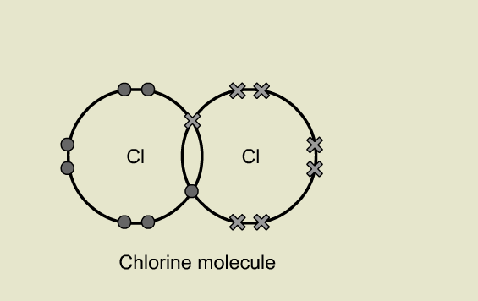
Double covalent bond
A double bond is when two atoms share two pairs of electrons with each other.
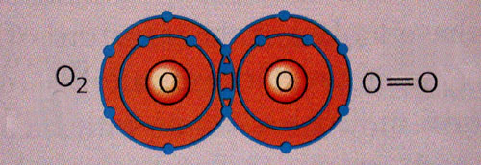
Triple bond
A triple bond is when three pairs of electrons are shared between two atoms in a molecule.
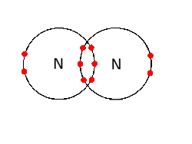
Covalent compounds
The compounds which are formed by sharing of electrons pair between two atoms are known as covalent compounds. Example: CH₄, H₂, O₂, etc.
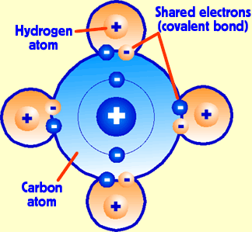

Characteristics of Covalent compounds
- The melting and boiling points of covalent compounds are low because their intermolecular forces are weak and less amount of energy is required to overcome these forces.
- The covalent compounds are generally poor conductors of electricity because the electrons are shared between atoms and no charged particles are formed in their solution.
Allotropy
The phenomenon in which one element exists in two or more forms having same chemical properties but different physical properties is called allotropy. The substances that show allotropy are carbon, sulphur, etc.
Allotropes The different forms of an element having same chemical properties but different physical properties are called allotropes.
Allotropes of Carbon
Carbon has three allotropes – graphite, diamond and Buckminster Fullerene.
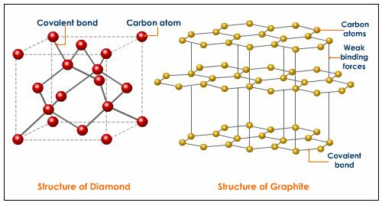
Graphite
In graphite, the carbon atoms are arranged in flat parallel layers as regular hexagons. Each carbon in these layers is bonded to three others by covalent bonds. Graphite thus acquires some double bond character. Each layer is bonded to adjacent layers by weak van der Waals forces. This allows each layer to slide over the other easily. Due to this type of structure graphite is soft and slippery, and can act as a lubricant.
Uses of graphite
- It is used in lead pencils as it is soft and leaves black mark on the paper.
- It, being a good conductor of electricity, is used in making electrode in the cells.
- Powdered graphite is used as lubricant because it is very soft and can withstand at high temperature.

Diamond
In diamond, each carbon atom is joined to four other carbon atoms in tetrahedral manner. Three tetrahedral joined to form a puckered six member ring and capped by four tetrahedral to form a large structure. Repetition of this structure forms a three-dimensional structure as shown here. So, it is covalent network solid which is hardest substances.
Uses of diamond
- It is used in pencils for cutting glass etc because it is the hardest substance known.
- It is used for making dies for drawing thin wires.
- It is used in surgical tools.
- It is used for making jewellery because of high refractive index.
Difference of Diamond and graphite
Graphite | Diamond
Graphite has two dimensional structure | Diamond is a three dimensional structure.
Soft and greasy. | It is the hardest substance known.
It is a good conductor of heat and electricity. | It is the bad conductor of electricity but good conductor of heat.
It is grayish black substance. | It is transparent.

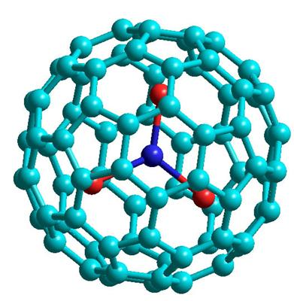
Fullerenes
Fullerenes form another class of carbon allotropes. The first one to be identified was C-60 which has carbon atoms arranged in the shape of a football. It contains 5 rings membered and six rings membered of carbon atoms.

Versatile nature of carbon
Catenation
The property of self linking of carbon atoms through covalent bonds to form long chains or rings is called catenation.
Other element which shows the catenation property is silicon.
The bonds formed between the carbon and other elements are very strong because small size of carbon enables the nucleus to hold on to shared-pair of electron strongly.
Catenation – self linking of carbon atoms to form long chains or rings.
Tetravalency
sharing of 4 electrons with other atoms of carbon or any other monovalent element.
Classification of hydrocarbons
Heteroatom In hydrocarbons, the elements like halogen, oxygen, etc replacing hydrogen is called heteroatom. They are also present in some groups.
When a hydrogen atom is removed from an alkane, the group obtained is called an alkyl group.
Hydrocarbons
- The carbon compounds which contain only hydrogen and carbon are called
- Hydrocarbons which contain only single bonds between the carbon atoms are called alkanes. Their general formula is C_{n}H_{2n+2}.
- Hydrocarbons which contain one or more double bonds between the carbon atoms are called alkenes. Their general formula is C_{n}H_{2n}.
- Hydrocarbons which contain one or more triple bonds between the carbon atoms are called alkynes. Their general formula is C_{n}H_{2n-2}.
Saturated Carbon Compounds
Compounds of carbon which have only single bonds between the carbon atoms are called saturated carbon compounds.
Example: methane, ethane, etc.
Unsaturated carbon compounds
Compounds of carbon which have double or triple bonds between the carbon atoms are called unsaturated carbon compounds.
Example: ethene, ethyne, etc.
Straight chain compounds
Carbon compounds in which no carbon atom of the chain is linked to more than two other carbon atoms are called straight chain compounds.
E.g. methane, ethane, propane, etc.
Branched chain compounds
Carbon compounds, in which at least one carbon atom of the chain is linked to three or four other carbon atoms are called branched chain compounds. E.g. 2-methylpropane.
Cyclic compounds
Carbon compounds in which carbon atoms are arranged in a ring are called cyclic compounds. These are of two types –
Saturated cyclic compounds. E.g. cyclopropane, cyclobutane, cyclopentane, etc.
Unsaturated cyclic compounds. E.g. benzene.
Functional group
An atom or group of atoms present in a molecule which determines its functions or chemical properties is called a functional group. It is the most reactive site of a carbon compound.
Homologous series
The family of organic compounds having same functional group, similar chemical properties and the successive members of which differ by CH2 group is called a homologous series.
Characteristics of a homologous series
- All the members can be represented by same general formula.
- The molecular formulae of two successive members differ by -CH₂ group or by 14u.
- All the members have same functional group.
- All the members show similar chemical properties.
- The melting and boiling points of the members of homologous series increase gradually because their molecular masses increase.

Isomerism
The phenomenon in which a compound can be represented by different structures having different properties is called isomerism.
Isomers The compounds which can be represented by different structures having different properties are called isomers.
IUPAC – International union applied Pure Chemistry
The hydrocarbons are named in according to IUPAC convention. In the naming of hydrocarbons the following rules are used.
Select the parent carbon chain:
- Select the longest carbon chain as the parent chain.
- If a double or a triple bond is present in the carbon chain, it should be included in the parent chain.
- Number the parent carbon chain from that carbon end such that the double bond, triple bond or side chain gets the lowest number.
- Identify and name the side chain if any: -CH₃ is named as methyl, -C₂H₅ is named as ethyl etc. Also identify the position of the side chain.
Write the name of the hydrocarbon as:
- Position number-name of the side chain word root – Position
- Suffix: Depends on the type of carbon – carbon bond: for single
- bond, suffix is –ane ; for double bond, suffix is –ene, and for triple
- bond suffix is –yne

Chemical Properties of Carbon Compounds
Combustion
The process of heating a substance strongly in the presence of excess of oxygen or air is called combustion.
Carbon and carbon compounds release carbon dioxide, water and a large amount of heat and light on burning.
C + O₂ → CO₂ + Heat and Light
CH₄ + O₂ → CO₂ + H₂O + Heat and Light
C₂H₅OH + O₂ → CO₂ + H₂O + Heat and Light

- Saturated hydrocarbons generally give a clean blue flame because complete combustion of these substances takes place.
- Saturated hydrocarbons burn with a yellow flame and lots of black smoke due to the incomplete combustion of carbon contents.
- Condition in which saturated carbon compounds burn with sooty flame – If a saturated carbon compound is burnt in limited (insufficient) supply of air, it burns with sooty flame due to incomplete combustion.
- The gas/kerosene stoves used at homes have inlets for air so that a sufficient oxygen rich mixture is burnt to give a clean blue flame with a lot of heat.
- Sometimes bottoms of cooking vessels get blackened due to incomplete combustion of gas/kerosene. It means the holes are blocked. This problem can be removed by cleaning the burner by opening holes.
- The pollutants released in the environment by burning coal and petroleum are oxides of sulphur and nitrogen e.g. SO₂ , NO, NO₂ , etc.
- Combustion of hydrocarbons is regarded as oxidation reaction because during combustion, carbon is oxidised to CO₂ and hydrogen is oxidised to water by addition of oxygen.
- Only the gaseous substances produce flame on burning.
- Wood and charcoal are solid but they produce flame when ignited because when they are ignited the volatile substances present vaporize and burn with a flame in the beginning only.

Fossil fuels
The fuels formed by the dead animals and plants buried under the earth millions of years ago due to intense heat and pressure are called fossil fuels. E.g. coal and petroleum.
When an alcohol is heated in the presence of alkaline KMnO4 (or acidified K2 Cr2 O7 ) then corresponding carboxylic acid is formed.

Addition reaction
The reaction which involves addition of two reactants to form a single product is called an addition reaction. Only unsaturated hydrocarbons perform addition reactions.
CH₂ = CH₂ + Cl₂ CH₂Cl – CH₂Cl
Industrial application of addition reaction Addition reaction is commonly used in the hydrogenation of vegetable oils using a nickel catalyst to form vegetable ghee.
Vegetable oil (liquid) + H₂ Ni (473K) Vegetable ghee (solid)
Saturated fatty acids are harmful for health so oils containing unsaturated fatty acids should be used for cooking because Saturated fats increase the level of bad cholesterol (low density lipoprotein LDL) in blood which sticks to the walls of arteries and causes heart diseases.
Substitution reaction
The reaction which involves direct replacement of an atom or group of atoms in an original molecule is called substitution reaction. Only saturated hydrocarbons perform substitution reactions.
CH₄ + Cl₂ CH₃Cl + HCl

Functional group | Symbol/formula | Prefix/suffix | Compound name
Halo | -Cl, -Br, - I | Halo (prefix) | Haloalkane
Alcohol | -OH | -ol | Alkanol
Aldehyde | -CHO | -al | alkanal
Ketone | - CO - | -one | Alkanone
Carboxylic | -COOH | -oic acid | Alkanoic acid

Simplest compound | Common name | IUPAC name | Formula
Alcohol | Methyl alcohol | Methanol | CH₃OH
Aldehyde | Formaldehyde | Methanal | HCHO
Ketone | Acetone | Propanone | CH₃COCH₃
Carboxylic acid | Formic acid | Methanoic acid | HCOOH
alkane | Methane | Methane | CH₄
Alkene | Ethylene | Ethene | C₂H₄
alkyne | Acetylene | Ethyne | C₂H₂

Ethanol (CH₃CH₂OH or C₂H₅OH)
Physical properties
- It is liquid at room temperature.
- It is colourless and has distinct smell and burning taste.
- It is soluble in water in all proportions.
Chemical properties
- It reacts with sodium to form sodium ethoxide and hydrogen gas.
2CH₃CH₂OH + 2Na 2CH₃CH₂ONa + H₂
- It reacts with hot concentrated H2SO4 to give ethene.
CH₃CH₂OH CH₂=CH₂ + H₂O
USES
- It is used in all alcoholic drinks like wine, beer, etc.
- In the form of rectified spirit (95% alcohol + 5% water), it is used as an antiseptic for wounds.
- It is used in medicines like tincture iodine, cough syrups, tonics etc because it is a good solvent.
- In cold countries it is used as antifreeze in automobiles.
Harmful effects of ethanol
- Consumption of its small quantity causes drunkenness.
- It depresses the central nervous system which results in mental confusion and drowsiness.
- It damages liver and kidney.
- It decreases the sense of judgment and sense of timing.
- It increases crime in the society.
Denatured alcohol
To prevent the misuse of ethanol produced for industrial use, it is made unfit for drinking by adding poisonous substances like methanol, copper sulphate, etc. it is called denatured alcohol.

Ethanoic acid (acetic acid or vinegar, CH₃COOH)
Physical properties.
- It is a colourless and pungent smelling liquid.
- Its melting point is 290K so it often freezes during winter and looks like glacier. Therefore, it is also known as glacial acetic acid.
- It is soluble in water in all proportions.
5% to 8% solution of Ethanoic acid in water is called vinegar.
Chemical properties
- Reaction with alcohol. Ethanoic acid reacts with ethanol in the presence of an acid to give ester.
CH₂COOH + C₂H₅OH CH₃COOC₂H₅ + H₂O
- Reaction with base: Ethanoic acid reacts with sodium hydroxide to give sodium ethanoate (sodium acetate) and water.
CH₃COOH + NaOH CH₃OONa + H₂O
- Reaction with carbonates and bicarbonates: Ethanoic acid reacts with carbonates and bicarbonates to salt carbon dioxide and water.
2CH₃COOH + Na₂CO₃ 2CH₃COONa + CO₂ + H₂O
CH₃COOH + NaHCO₃ CH₃COONa + CO₂ + H₂O
Esterification
The reaction between a carboxylic acid and an alcohol to form an ester is called Esterification reaction.
CH₂COOH + C₂H₅OH CH₃COOC₂H₅ + H₂O
The reaction between the ester and hot base to give original alcohol and carboxylic acid back is called saponification reaction because this reaction is used in preparing soaps.
CH₃COOC₂H₅ + NaOH CH₂COOH + C₂H₅OH
The product formed when a carboxylic acid reacts with an alcohol having the formula R-COO-R’ is called an ester. Esters are sweet smelling substances. They are widely spread in nature. The smell of fruits and flowers is due to the presence of esters. Esters are used as flavorings agents and in making perfumes.
Cleansing action of soap
The molecules of soap are sodium or potassium salts of long chain of carboxylic acids. The hydrocarbon tail being hydrophobic reacts with oil or grease while the ionic end being hydrophilic reacts with water. As a result micelles are formed. They form an emulsion in water.
When the surface of clothes is beaten or agitated, micelles are thrown away and the cloth is cleaned.
Micelle
The cluster of about 100 – 200 molecules with hydrophilic ends on the surface of cluster and hydrophobic ends towards the centre, is called a micelle.

Soaps |  | Detergents
Soaps are sodium salts of long chain carboxylic acids. |  | Detergents are sodium salts of long chain sulphonic acids.
Soaps do not form leather with hard water. |  | Detergents form leather with hard water.
Soaps are biodegradable. |  | They are non biodegradable.
Soaps do not have strong cleansing action. |  | They have strong cleansing action.
These are prepared from animal fats. |  | They are prepared from hydrocarbons of petroleum.

Advantage of soaps over detergents: Soaps are biodegradable so they do not produce pollution. While detergents being non biodegradable produce pollution.
Advantage of detergents over soaps: Detergents can be used in hard water. Also, they have strong cleansing action. While soaps have weak cleansing action and they cannot be used in hard water.

