MENSURATION

In the earlier classes, we learnt about plane figures. In this chapter we shall deal with the boundary and region covered by the plane figures.

Perimeter of a Closed Figure
Perimeter of a closed figure is the distance covered along its boundary when we go around it once. It units are m, cm, etc. To find the perimeter of a given figure, we simply add all its sides.
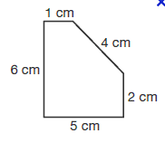
Example: Let us find the perimeter of the given figure.
Solution:

Perimeter of ABCDE = AB + BC + CD + DE + EA
= (5 + 2 + 4 + 1 + 6) cm
= 18 cm.

Perimeter of a Rectangle
A rectangle is a quadrilateral whose opposite sides are equal.
Perimeter of the rectangle = Sum of the length of its four sides.
= AB + BC + CD + DA
= AB + BC + AB + BC (∵ AB = CD and BC = DA)
=2 × AB + 2 × BC
= 2 × (AB + BC)
= 2 × (Length + Breadth)
So,
Perimeter of rectangle = 2 × (Length + Breadth)

Example: The length and breadth of a rectangular park is 18 m and 12 m. Find the perimeter of the park. Also, find the cost of fencing the park at the rate of Rs 25 per m.
Solution: Perimeter of the rectangular park = 2 × (Length + Breadth)
= 2 × (18 + 12) m
= 2 × 30 m =60 m
Cost of fencing = Rs 25 per m
Cost of fencing 60 m = Rs 25 × 60 = Rs 1500
Example: The perimeter of a 15 cm long rectangle is 36 cm. Find the breadth of the rectangle.
Solution: Perimeter of the rectangular park = 2 × (Length + Breadth)
= 2 × (18 + 12) m
= 2 × 30 m = 60 m

Perimeter of Regular Shapes
Figures having all the sides of equal length and all the angles of equal measure are known as regular closed figures. For example, an equilateral triangle, a square, a regular hexagon, etc.
Regular  Shapes | Number of sides
Equilateral triangle | 3
Square | 4
Pentagon | 5
Hexagon | 6
Heptagon | 7
Octagon | 8
Nonagon | 9
Decagon | 10
Perimeter of a closed regular polygon
= Number of sides of the polygon × Length of each side.

Example: What is the perimeter of a regular hexagon with side 5cm?
Solution: Number of sides in a regular hexagon = 6
Length of each side = 5 cm
∴ Perimeter of the regular hexagon = 6 × 5 cm
= 30 cm
Example: The perimeter of a regular pentagon is 45 cm. Find the length of each side.
Solution: Number of sides in a regular pentagon = 5
Perimeter of the regular pentagon = 45 cm
We know,
Perimeter of a regular pentagon = 5 × Length of each side.
∴ Length of each side = 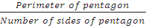
= = 9cm

Square: It is a regular polygon with four equal sides.
Perimeter of a square = 4 × Length of each side

Example: Find the perimeter of a square with side 4 cm.
Solution: Perimeter of square = 4 × Length of each side
= 4 × 4 cm
= 16 cm

Equilateral triangle: It is a regular polygon with three equal sides.
Perimeter of an Equilateral Triangle = 3 × Length of each side

Example: Find the cost of fencing a field which is in the shape of an equilateral triangle with side 22 m each at the rate of Rs 55 per metre.
Solution: Perimeter of an equilateral triangle = 3 × Length of each side
= 3 × 22 m
= 66 m
Cost of fencing = Rs 55 per metre
Cost of fencing 66 m = Rs 55 × 66 = Rs 3630

Area of a Closed Figure
Area of a closed figure is the region enclosed by the closed figure. Area is always expressed in terms of square units such as square m or square cm.

Area using a Squared Paper

We can calculate the area of a closed figure, by following the steps given below:
Step 1: Firstly, we place the closed figure on a squared paper or a graph paper where every square measures 1 cm × 1 cm.
Step 2: Then we make an outline of the figure.
Step 3: Now we look at the squares enclosed by the figure. Some of them are completely enclosed, some half, some less than half and some more than half. Note down the number of squares of each category.
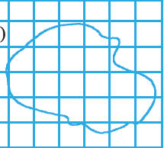
Step 4: Calculate the area of the closed figure by considering the following points.
(a) Take the area of 1 full square as 1 square unit.
(b) Ignore portions of the area that are less than half a square.
(c) If some portion enclosed by the figure is more than half a square, then count its area as one square unit.
(d) If exactly half of the square is counted, take its area as square unit.

Example: By counting squares, estimate the area of the figure.
Solution: Make an outline of the figure on the graph sheet.
Covered Area | Number | Area Estimate  (sq. units)
Area of a Rectangle
Area of Rectangle = Length × Breadth

Example: Find the area of a rectangular piece of cardboard whose length is 9 cm and breadth is 6 cm.
Solution: Area of rectangular piece of cardboard = Length × Breadth
= 9 cm × 6 cm
= 54 cm²
Area of a Square
Area of Square = Side × Side

Example: Find the area of a square plot of side 11m.
Solution: Area of square plot = Side × Side
= 11 m × 11 m
= 121 m²
Example: A floor is 5 m long and 3 m wide. How many square titles, each of side 0.5 m, are required to cover the floor of the room?
Solution: Total area of the square tiles will be equal to the area of the room.
Area of the floor of the room = Length × Breadth
= 5 m × 3 m
= 15 m²
Area of 1 square tile = Side × Side
= 0.5 m × 0.5 m
= 0.25 m²
Now, Area of floor = Number of square tiles × Area of 1 tile
∴ Number of square tiles = 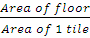
= 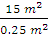
= = 60 tiles
Example: Find the area of the given figure by splitting the figure into rectangles.
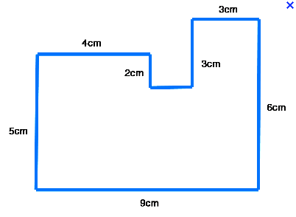
Solution: By splitting the figures into rectangles, we will get the following figure.
I
II
III
Are of the given figure = Area of Rectangle I + Area of Rectangle II + Area of Rectangle III
= 5 cm × 4 cm + 3 cm × 2 cm + 6 cm × 2 cm
= 20 cm² + 6 cm² + 12 cm²
= 38 cm²

