Congruence of Triangles

Congruence of Plane Figures

A plane figure is any shape that can be drawn in two dimensions.
Examples: Rectangle, square, triangle, rhombus, etc.
If two objects are of exactly the same shape and size, they are said to be congruent and the relation of the two objects being congruent is called congruence.
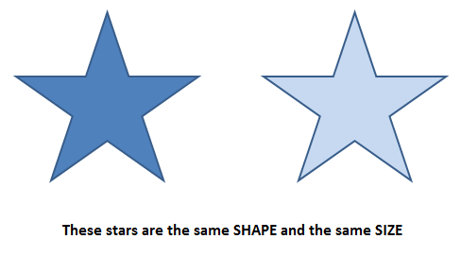
Or we can state it as: “Two plane figures are congruent if each, when superimposed on the other, covers it exactly.” Congruence is denoted by “≅”.
Congruence among Line Segments

Two line segments are said to be congruent if they have the same (or equal) length.

Look at this, Here the line segment CD completely covers the line segment AB. So, we say that the line segment AB is congruent to the line segment CD.
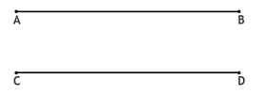
Also, we can see that EF is not congruent to CD and AB.
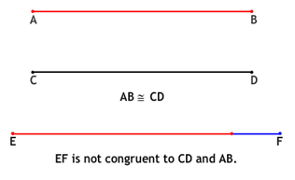

The converse of the above holds true, that is, if two line segments are congruent then they have same length.

Congruence of Angles

If two angles have the same measure, they are congruent. Also, if two angles are congruent, their measures are same.

Look at these four angles,
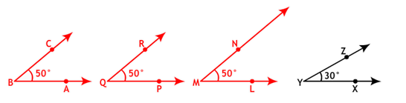

Here,

Congruence of Triangles

Triangles that have exactly the same size and shape are called congruent triangles.

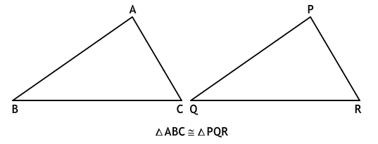

Two triangles are congruent when their corresponding sides and angles have the same measurements. This means that corresponding parts of congruent triangles are congruent (CPCTC).
Sides: AB = PQ

BC = QR

AC = PR

Angles: A = ∠ P

∠ B = ∠ Q

∠ C = ∠ R

Correspondence:
A P B Q C R

Or simply, ABC PQR

Criteria for Congruence of Triangles

To show that two triangles are congruent, we need not show the equality of all the six pairs of corresponding parts. We have the following methods for proving the congruence of triangles.

- Side-Side-Side (SSS) Congruence

- Side-Angle-Side (SAS) Congruence

- Angle-Side-Angle (ASA) Congruence

- Right angle-Hypotenuse-Side (RHS) Congruence

Side-Side-Side (SSS) Congruence: If three sides of one triangle are equal to three sides of another triangle, then the triangles are congruent.
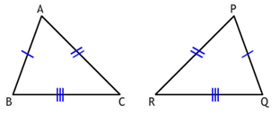
AB = PQ

BC = QR

AC = PR

∴ ∆ ABC ≅ ∆ PQR

Side-Angle-Side (SAS) Congruence: If two sides and the included angle of one triangle are equal to two sides and included angle of another triangle, then the triangles are congruent.
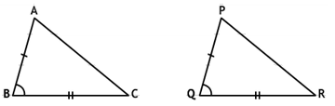
AB = PQ

∠ B = ∠ Q

BC = QR

∴ ∆ ABC ≅ ∆ PQR

Angle-Side-Angle (ASA) Congruence: If two angles and the included side of one triangle are equal to two angles and included side of another triangle, then the triangles are congruent.
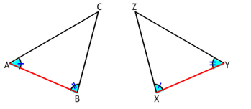
A = ∠ X

AB = XY

∠ B = ∠ Y

∆ ABC ≅ ∆ PQR

Congruence among Right-Angled Triangles

Right angle-Hypotenuse-Side (RHS) Congruence: Two right – angled triangles are said to be congruent under a correspondence if the hypotenuse and side of one right – angled triangle is equal to the hypotenuse and one side of the other right – angled triangle.
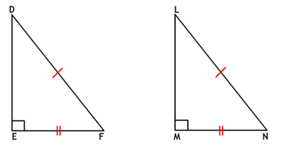
E = ∠ M = ∠ 90°

DF = LM

EF = MN

∴ ∆ DEF ≅ ∆ LMN

It is not necessary that the right angle is included between the two sides taken.

We can take the hypotenuse and any one of the other two sides of a right – angled triangle to apply the RHS criterion.

