Simple Equation

A variable is a number which does not have a fixed value, that is, it can take different numerical value. Variables are denoted usually by letters of the alphabet.
For example: x, y, z, l, m, n, p etc.

An equation is a condition on a variable. It has an equality sign. The value of the expression on the left hand side (L.H.S) and the right hand side (R.H.S) must be equal.

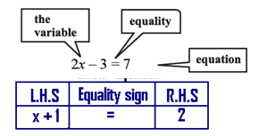
Example:

Write the following statements in the form of equations:

(i) The sum of three times x and 11 is 32.

(ii) If you subtract 5 from 6 times a number, you get 7.

(iii) One fourth of m is 3 more than 7.

(iv) One third of a number plus 5 is 8.

Solution:

(i) Three times x is 3x.

Sum of 3x and 11 is 3x + 11. The sum is 32.

The equation is 3x + 11 = 32.

(ii) Let us say the number is z; z multiplied by 6 is 6z.

Subtracting 5 from 6z, one gets 6z – 5. The result is 7.

The equation is 6z – 5 = 7

(iii) One fourth of m is m/4 .
It is greater than 7 by 3. This means the difference (m/4-7) is 3.

The equation is m/4-7 = 3.

(iv) Take the number to be n. One third of n is n/3.

The number plus 5 is n/3 + 5. It is 8.

The equation is n/3 + 5 = 8.

Example:

Write the following statements in the form of equations:
(a) The sum of 10 times x and 5 is 55.
(b) If you subtract 8 from 3 times m, you get 22.
(c) The sum of x and 2, divided by 4 gives 50.
(d) One third of a number minus 6 gives 25.
Solution:
(a). 10x + 5 = 55
(b). 3m – 8 = 22
(c). (x+2)/4 = 50
(d). x/3 - 6= 25
Example: Convert the following in statement form:
(a) x + 5 = 15
(b) 3x – 4 = 12
(c) 5y/4 = 20
(d) 4p-12 = 8
Solution:
(a) The sum of x and 5 gives 15.
(b) Subtract 4 from 3 times x to get 12.
(c) Times y gives 20.
d) Taking away 12 from 4 times p gives 8.
Solving an Equation
Finding the value of a numeral that makes a statement true is said to be solving the equation.In the following sections, we will consider solving equation involving addition, subtraction, multiplication and division.

Equations Involving Addition
Consider the equation
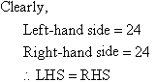
If we subtract 8 from both sides of the equation, then we obtain:
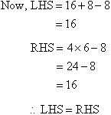
We notice that the statement 16 + 8 = 4 x 6 remains a true statement when 8 is subtracted from both sides of the equation.
This suggests that equations behave like a balance. If the same mass is taken away from both scales of a balance, it still remains balanced. This implies that we can subtract the same number from both sides of an equation to get a new equation.
Consider the equation x + 3 = 7.
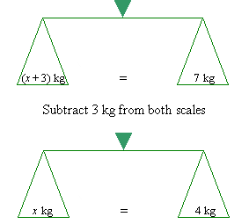

From the preceding discussion, we can state that:
The same number can be subtracted from both sides of an equation.
Example: Say whether the equation is satisfied:
(a) x + 5 = 0 ; x = 5
(b) x + 10 = 0; x = -10
(c) 3x = 0; x = 0
(d) 5x = 15; x = -3
(e) m/3 = 15; m = 45
Solution:
(a) 5 + 5 = 10 ≠ 0
∴Equation is not satisfied.
(b) -10 + 10 = 0
∴ Equation is satisfied.
(c) 3 × 0 = 0
∴ Equation is satisfied.
(d) 5 × -3 = -15 ≠ 15
∴Equation is not satisfied.
(e) 45/3= 15
∴ Equation is not satisfied.

