Lines and Angle
Introduction
Line: A straight path that goes on forever in opposite directions.
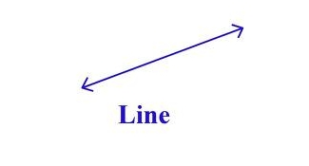
Line Segments: A line segment is a Part of a line with two endpoints.
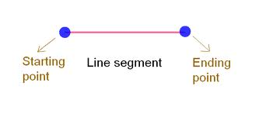
Ray: A ray is a part of a line that has one endpoint and goes on forever in only one direction.
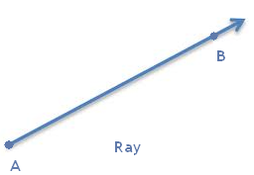
Related Angles
Complementary Angles
If the sum of measures of angle is 90°, then the two angles said to be complementary to each other or a pair of complementary angles.

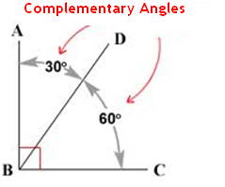
Supplementary Angles
If the sum of measures of angle is 180°, then the two angles said to be supplementary to each other or a pair of supplement angles.
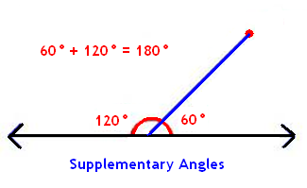
Adjacent Angles
Angles that share a common side, have the same vertex, and do not overlap.
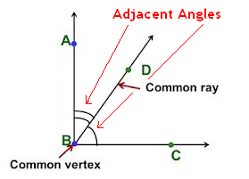
Conditions for adjacent angles are:

- They have a common vertex

- They have a common arm

- The non-common arms are on either side of the common arm.
Linear Pair

A linear pair is a pair of adjacent angles whose non-common sides are opposite rays.
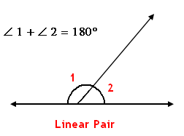
Vertically Opposite Angles
A pair of non-adjacent angles formed by the intersection of two straight lines is known as the pair of vertically opposite angle.
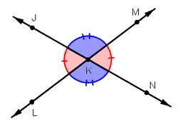
∠JKL = ∠MKN and ∠JKM = ∠LKN are pairs of vertical angles
Pairs of Lines
Intersecting Lines
Lines that have one and only one point in common are known as intersecting lines.

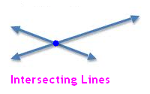
Transversal
A line that intersects two or more lines at distinct points is called a transversal.
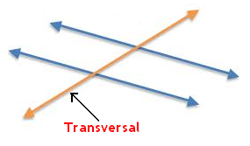
Angles Made By a Transversal
From these figure, you can see lines l and m cut by transversal p. The eight angles marked 1 to 8 have their special names:
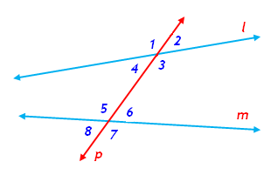

Interior angles | ∠3, ∠ 4, ∠ 5, ∠ 6
Exterior angles | ∠ 1 ∠ 2 ∠ 7 ∠ 8
Pairs of corresponding angles | ∠ 1 and ∠5, ∠2 and ∠6, ∠3 and ∠7, ∠4 and ∠8
Pairs of Alternate interior angles | ∠3 and ∠ 6, ∠ 4 and ∠ 5
Pairs of Alternate exterior angles | ∠ 1 and ∠ 8, ∠ 2 and ∠ 7
Pair of interior angles on the same side of the transversal | ∠ 3 and ∠ 5, ∠ 4 and ∠ 6

Transversal of Parallel Lines
- If two parallel lines are cut by a transversal each pair of corresponding angles are equal in measure.

- If two parallel lines are cut by a transversal each pair of alternate interior angles are equal.

- If two parallel lines are cut by a transversal, then each pair of interior angles on the same side of the transversal are supplementary.

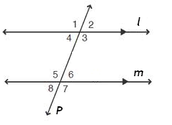

Checking For Parallel Lines
When a transversal cuts two lines, such that pairs of corresponding angles are equal, then the lines have to be parallel.

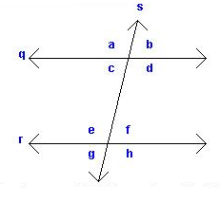

When a transversal cuts two lines, such that pairs of alternate interior angles are equal, the lines have to be parallel.

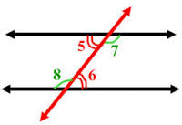

When a transversal cuts two lines, such that pairs of interior angles on the same side of the transversal are supplementary, the lines have to be parallel.

