**HANDICRAFT ASPECTS.**

|  |
| --- |
| [Strengths](http://as.ori.nic.in/dhorissa/hc_intro.htm# Strengths )      [Weaknesses](http://as.ori.nic.in/dhorissa/hc_intro.htm#Weaknesses)     [Opportunity](http://as.ori.nic.in/dhorissa/hc_intro.htm# Opportunity.  )     [Threat](http://as.ori.nic.in/dhorissa/hc_intro.htm#Threat) |

|  |
| --- |
| [Intervention strategies adopted](http://as.ori.nic.in/dhorissa/hc_intro.htm#Intervention strategies adopted) |

Handicrafts are a part of India’s rich cultural heritage. These are mainly works of art and beauty, designed and shaped by hand with creative imagination of craft-persons from time immemorial. Our country is best known for its handicraft, which flourished with Royal Patronage in ancient days. Sweeping wave of industrialization and consequential flooding of market with machine-made goods could not put this craft sector to oblivion. Immediately after independence the planners felt that co-existence of craft industries with modern factories would go a long way in mitigating the problems of employment and poverty in a labour abundant and capital scarce country like ours. The All India Handicrafts Board was established in the year 1952 to look after promotion and development of handicraft in India.

              Orissa is endowed with varieties of crafts mainly linked to a number of festivities and rituals observed in our state. The superb art and skill displayed by our artisan in temples, mathas and sculptures of the past have been enthrilling the visitors over the centuries. Orissa handicrafts, due to their unique, original, creative characteristics and unsurpassed sense of colour are offered a place of pride in Indian Handicraft Map.  There are over a lakh of handicraft artisans in the state practising as many as 49 crafts. There are a number of craft pockets dispersed throughout the state. These artisans produce handicraft goods valued over Rs.7, 000.00 in lakhs annually. Around 22,000 artisans have been brought into Co-operative fold by organising 290 Co-operative Societies at grass-root level. Steps are also being taken to form Self Help Groups of the handicraft artisans to ensure community participation. At the State Level Orissa State Co-operative Handicrafts Corporation has been formed as an Apex body to look after marketing of handicraft goods. That apart, they also under-take other developmental activities for promotion of handicrafts.

        110 Master Craft persons of the state have got recognition at the National level by winning National Award and National Merit Certificates. One of them has been conferred with Padma Bhusan while other two have been awarded Padma-shree. Besides, 117 Master-craft persons have received State Award and State Award Merit Certificate. The awards no doubt are recognition excellence achieved by our craftsmen in the field of handicrafts. Even some of the craft-persons have successfully conducted craft demonstration in foreign countries and got wide applauds.

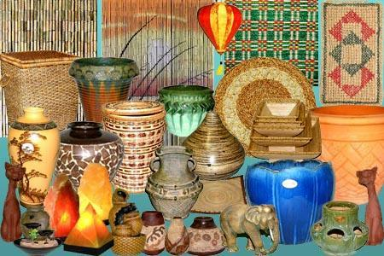 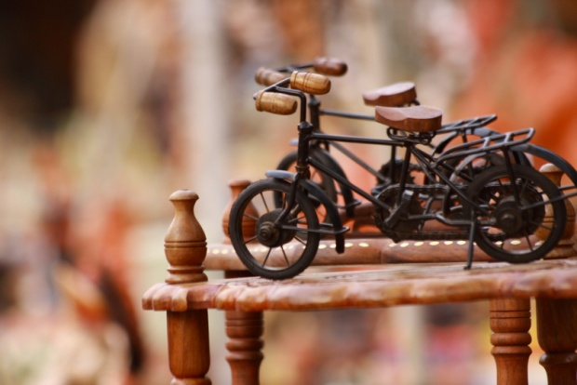

        It is seen that some of the Crafts like stone carving, wood carving patta painting, silver filigree, applique, tribal jewellery, papier machie, terracotta, Dhokra casting, wooden painted items, cane & bamboo products. Brass & bell metal products, golden grass products are to name a few only have potential to grow into serious commercial venture. It is also admitted that some crafts are found languishing due to various problems, which necessitate product diversification, design development, technology up-gradation, proper market exploitation etc.  The handicraft sector at present operates with the following strengths weaknesses, opportunities and threats. The points as made out below leads us to make a SWOT analysis and suggest measures to be taken.

**Strengths**

•                  Availability of a major cross-section of craft-persons with desired level of skill and competence.

•                  Low level of investment with little gestation period.

•                  Generation of self-employment in rural and urban areas.

•                  No/less power utilised in production process.

•                  High ratio of value addition to investment.

•                  Economic empowerment of women.

•                  Utilisation of local resources.

•                  Adoption of appropriate technology.

•                  Eco-friendly.

•                  Product with adequate demand in domestic as well as external market.

**Weaknesses..**

•                  Highly unorganised and widely dispersed.

•                  Lack of opportunity/unwillingness for adoption to: -

(a) Market oriented designs.

(b) Production diversification.

(c) Cross-culture innovation.

(d) Advanced technology.

•                  Lack of exposure to different market segments.

•                  Lack of enterprising and marketing skill.

•                  In-adequate market intelligence.

•                  Non-conducive policies on utilisation of forest and mineral based raw-materials.

•                  In-adequate institutional credit flow leading to exploitative lending.

•                  Inability of timely execution of large orders.

•                  Lack of proper branding of products resulting in duplication.

•                  Lack of awareness and measures for quality assurance.

**Opportunity**

a)      Availability of Manpower/Labour force.

b)      Ample scope of Govt. schematic support for artisans under various schemes

c)      High export potential.

d)      Least impact of WTO in this sector.

e)      Availability of traditional skill. Least impact of WTO in this sector.

**Threat**

a)      Imitation by other States due to lack of patenting.

b)      Frequent occurrence of natural calamity.

c)      Seasonal availability of raw materials like golden grass, needing huge fund for due time procurement.

d)      Seasonal employment in Crafts like Terracotta.

e)      High illiteracy rate to adjust with the charged scenario,

The strength and opportunity surpasses the weakness and threat. However to over come the threat and weakness both the Central and State Govt. have implemented various schemes with following intervention strategies for development of this sector.

**Intervention strategies adopted**

•                  Development of clusters into S.H.Gs/Co-operatives to encourage community participation and capacity building.

•                  Induction of new artisans through transfer of skill.

•                  Appropriate measures for skill up gradation of artisans (Craft-wise).

•                  Technology upgradation.

•                  Creation of facility for easy and timely access to raw materials.

•                  Use of expert service for innovative designs.

•                  Establishment of marketing linkage with emphasis on export promotion.

•                  Institutional credit linkage.

•                  Strengthening/creation of infrastructure:

(Raw-material base/Common Facility, Centre/Design Centre/finished product godown/market outlets/ Work shed.)

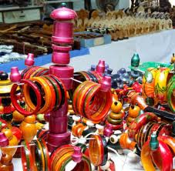                  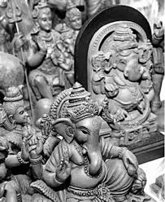

•                  Strengthening & streamlining database and information system.

•                  Strengthening the existing monitoring and supervision system.

•                  Networking at artisan level/cluster level/District level/State-level.

•                  Synergy among development partners to ensure dovetailing of funds /efforts for better result.

•                  Expansion of P.R. base.

•                  Development of connectivity of craft clusters.

•                  I.P.R. benefits.

