Food: Where Does It Come From?
Animals Nutrition
The cow eats the grass while a lion eats a deer and a crow eats both grains as wells as rat. It is clear that different animals eat different food types. On the basis of the type of food they eat animals are divided into three categories.
They are: Herbivore, carnivore and Omnivore

Herbivore- These animals eat only plants. Examples are cow, horse deer.
Carnivore- Animals which eat flesh of other animals are called carnivore. For e.g. lion, leopard, tiger etc.
Omnivore- These are the animals eat both plants as well as the animals like the crow and pigeon.

Given below are the pictures of various animals. Write the food they eat and also the category to which they belong to.
Animal | Food | Type of animal
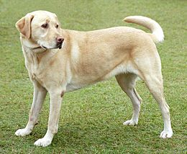 | Raw or cooked meat, organ meats, vegetables, grains and fruits. | Omnivore
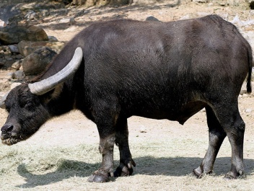 | Green leaves and grass | Herbivore
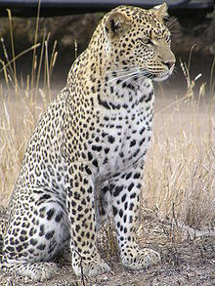 | Flesh of deer, zebra | Carnivore
 | Green leaves and grass | Herbivore
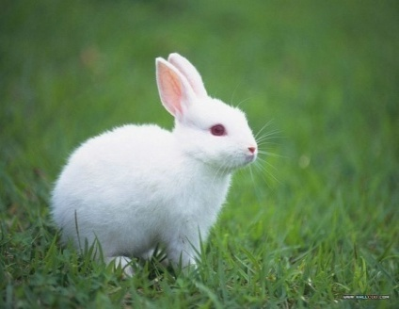 | Green leaves and vegetables | Herbivore
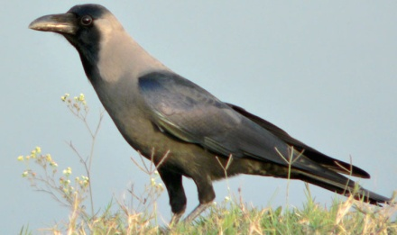 | Small animals like mouse, lizard | Omnivore

***********

