**CREATING PAGE NUMBERS**

Including the total number of pages

To include the total number of pages (as in **page 1 of 12**):

1. Type the word **page** and a space; then insert the page number as above.
2. Press the spacebar once, type the word **of** and add a space; then choose **Insert > Fields > Page Count**.

Restarting page numbering

Often you will want to restart the page numbering at 1, for example, on the page following a title page or a table of contents. In addition, many documents have the *front matter* (such as the table of contents) numbered with Roman numerals and the main body of the document numbered in Arabic numerals, starting with 1.

You can restart page numbering in two ways.

**Method 1:**

1. Place the cursor in the first paragraph of the new page.
2. Choose **Format > Paragraph**.
3. On the *Text Flow* page of the Paragraph dialog box, check **Insert** in the *Breaks* area.
4. In the *Type* drop-down list, select **Page**.
5. In the *Position* drop-down list, select **Before** or **After** to position where you want to insert the page break.
6. Check **With Page Style** and specify the page style to use.
7. Specify the page number to start from and then click **OK**.

**Method 2:**

1. Place the cursor in the first paragraph of the new page.
2. Choose **Insert > Manual break**.
3. **Page break** is the default selected on the Insert Break dialog box.
4. Choose the required page in the *Style* drop-down list.
5. Check **Change page number**.
6. Specify the page number to start from and then click **OK**.

[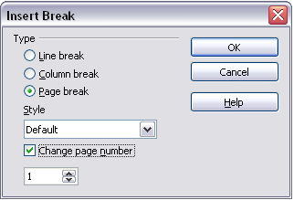](https://wiki.openoffice.org/wiki/File:Insert-break.png)

Restarting page numbering after a manual page break.

The following derives from experience with OOo 3.2.1:

If the "Default" page style doesn't behave as desired when applied to both sections, create two new page styles (which could be based on Default) with names such as "BodyPage" and "FrontMatter." Apply the BodyPage style to the page you want to start as "1" in the Arabic page number sequence. Apply the FrontMatter page style to the first page in the document you want to start with Roman page numbers.

When creating either page style, make the "Next Page" style the same as the one you create. That is, a FrontMatter page is followed by a FrontMatter format--until changed by a page break and a new style, such as BodyPage, which can continue to the end of the document.

When creating a page style based on Default, check to be sure you are not creating a paragraph format based on the Default paragraph style. Select from the list of Page Styles, not from Paragraph Styles where there is also a Default.

Changing the format of page numbers

To set the page number to display in Roman numerals, you need to specify the format of numbers in the page style.

On the *Page* page of the Page Style dialog box, in the *Layout settings* section, select **i, ii, iii, ...** from the *Format* drop-down list.

[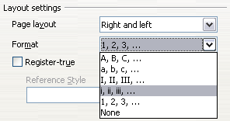](https://wiki.openoffice.org/wiki/File:LayoutSetting.png)

Changing format of page numbers.