**Creating headers and footers**

Headers are portions of a document that always appear at the top of a page; footers appear at the bottom of a page. Typically, headers display the title or chapter name of a document.

To insert a header, click **Insert > Header > Default** (or the page style, if not Default) as shown below.

[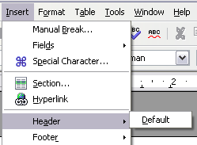](https://wiki.openoffice.org/wiki/File:HeaderFooter.png)

Inserting headers and footers.

Similarly, to insert a footer, choose **Footer**.

Depending on which option you choose, an area will appear at the top or bottom of the page where you can enter text. This text will appear at the top or bottom of every page.

Items, such as document titles, chapter titles, and page numbers, which often go into headers and footers, are best added as fields. That way, if something changes, the headers and footers are all updated automatically.

Here is one common example. To insert the document title into the header:

1. Select **File > Properties > Description,** enter a title for your document in the *Title* area, and click **OK** to close the dialog box.
2. Add a header (**Insert > Header > Default**).
3. Place the cursor in the header part of the page.
4. Select **Insert > Fields > Title**. The title should appear on a gray background (which does not show when printed and can be turned off).
5. To change the title for the whole document, choose **File > Properties > Description**.
6. OpenOffice.org uses a feature called *fields* to manage page numbers. To insert a page number field, position the cursor where you want to insert the number and choose **Insert > Fields > Page Number**. The page number appears with a gray background. The gray background denotes a field.
7. **Note:** The gray background is simply there to denote a field. This background is not printed. Choose **View > Field Shadings** (or press *Ctrl+F8*) to turn this feature off.
8. If you have seen lists in OOo, you might have noticed this gray background. OOo lists use fields. The page number field always displays the page number for the current page. If you see the words “Page number" instead of a number, press *Ctrl+F9*. This shortcut key toggles OOo between displaying the field's *contents* (what the field is for) and the field's *results*

## Inserting a header

In OOo, headers are specified by page styles.

1. Open the Page Style dialog box for the desired page style (right-click > **Modify**).
2. Select the **Header** tab.
3. Under *Header*, check **Header on** and click **OK**.

[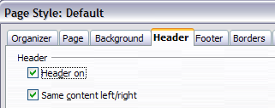](https://wiki.openoffice.org/wiki/File:WG6-29.png)  
*Turn on page header.*

At this point you should see the (empty) header on the current page. In the example below, the header area is identified, purely for illustrative purposes. It would normally be empty immediately after being turned on, until you insert your own header text and formatting.

[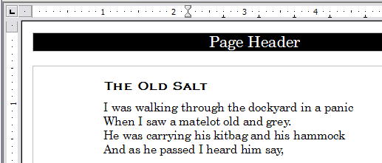](https://wiki.openoffice.org/wiki/File:WG6-30.png)  
*A page with a page header.*

*What's so special about headers?* The same text in the header appears on *all* pages with that page style. (You can experience this yourself by entering some text into the header.) This property of headers (or footers), along with fields, forms the basis of OOo page numbering.

**Tip:** You can also add a header through the Insert menu: **Insert > Header > [page style]**. Likewise, for footers: **Insert > Footer > [page style]**.

**Caution:** The Insert Menu can also be used for *deleting* a preexisting header or footer for a page style. If that page style has a check mark in front of it, pointing to it will open an OOo dialog box warning about this and asking whether you want to delete the header or footer for that particular page style.

## Simple page numbering

The simplest case is to have the page number at the top of every page and nothing more. To do this, put the cursor on the header and select **Insert > Fields > Page Number**.

[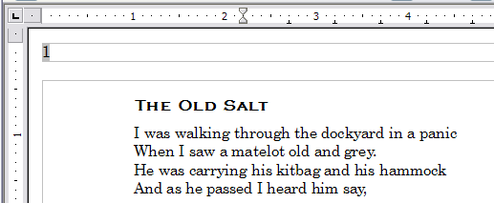](https://wiki.openoffice.org/wiki/File:WG6-31.png)  
*Page number inserted in the header.*