**NCERT Solution**

1. Fill in the blanks in the following.  
**Answer**

(i) Artificial magnets are made in different shapes such as Bar magnet , horse, shoe and cylindrical .

(ii) The Materials which are attracted towards a magnet are called magnetic.

(iii) Paper is not a magnetic material.

(iv) In olden days, sailors used to find direction by suspending a piece of magnet.

(v) A magnet always has two poles.

**2. State whether the following statements are True or False.**  
**Answer** :

(i) A cylindrical magnet has only one pole. (False)  
 (ii) Artificial magnets were discovered in Greece. (False)

(iii) Similar poles of a magnet repel each other. (True)

(iv) Maximum iron filings stick in the middle of a bar magnet when it is brought near them. (False)

(v) Bar magnets always point towards North-South direction. (False)

(vi) A compass can be used to find East-West direction at any place. (True)

(vii) Rubber is a magnetic material. (False)

**3. It was observed that a pencil sharpener gets attracted by both the poles of a magnet although its body is made of plastic. Name a material that might have been used to make some part of it.**

**Answer:** The blade of pencil of sharper is made up of iron. Iron is magnetic nature. That’s why the sharpener gets attracted by the poles of magnet.  
  
4. **Column I shows different positions in which one pole of a magnet is placed near that of the other. Column II indicates the resulting action between them for each situation. Fill in the blanks.**

**Answer:**

|  |  |
| --- | --- |
| **Column I** | **Column II** |
| N - N | **Repulsion** |
| N**-S** | Attraction |
| S-N | **Attraction** |
| S-S | **Repulsion** |

**5. Write any two properties of a magnet.**

**Answer:**

* Magnets attract objects made of magnetic materials like iron.
* Each magnet has two poles .i.e north pole (N) and south pole(P)
* Unlike poles attract each other and like poles repel each other.

**6. Where are poles of a bar magnet located?**

**Answer:**

The two end of the bar magnet represents the two poles.

7. **A bar magnet has no markings to indicate its poles. How would you find out near which end is its north pole located?**

**Answer:**

Hang up the magnet by a cotton thread so that it hangs freely. When it comes to rest, we notice that the magnet is lying in a North –South direction.

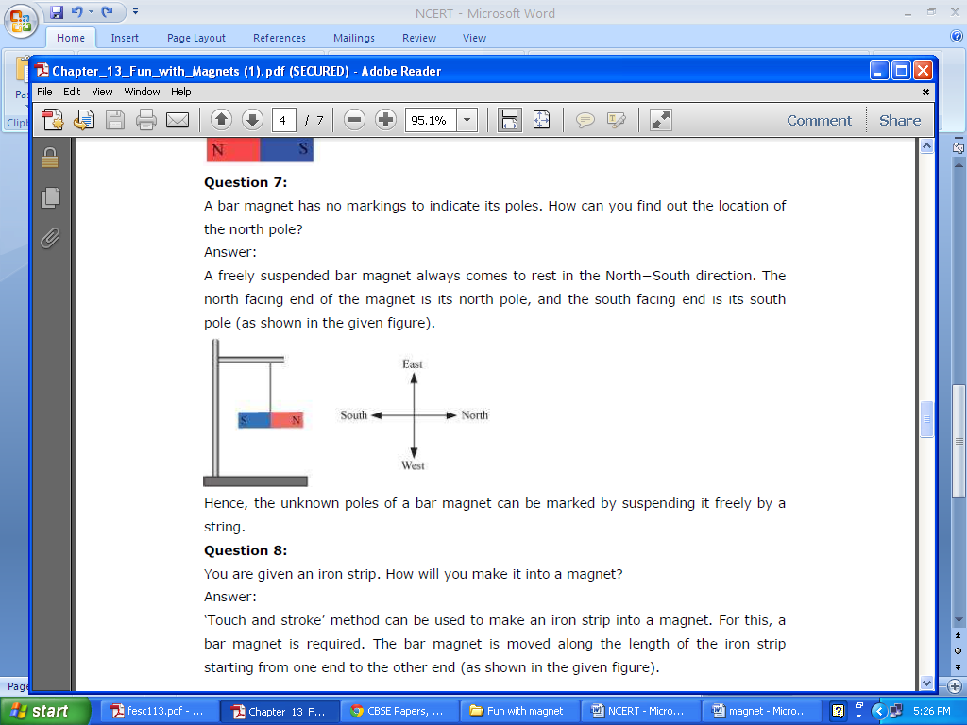

**8. You are given an iron strip. How will you make it into a magnet?**

**Answer:**

* Take a rectangular piece of iron and place it on the table.
* Take a bar magnet and place one of its poles near one edge of the bar of iron.
* Now rub the bar magnet 30-40 times over the iron bar.
* Bring the iron bar near the needle clips and check if it is converted to a magnet or not.

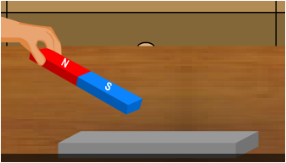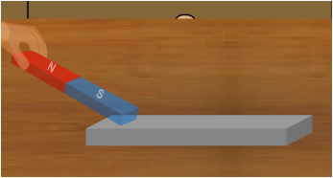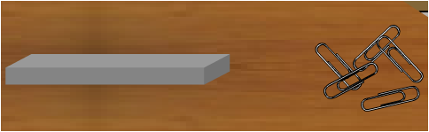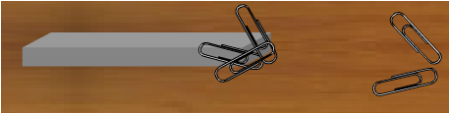

**9. How is a compass used to find directions?**

**Answer:**

A magnetic compass consists of a small pointed magnet which is suspended freely. A suspended magnet always aligns in N-S direction. The red coloured magnetic needle points to north direct. Once we know the north direction, we can find out the other direction i.e south directions. If North is upward then south is downward side. East will be on right hand side while West shall be left hand side.

10. **A magnet was brought from different directions towards a toy boat that has been floating in water in a tub. Affect observed in each case is stated in Column I. Possible reasons for the observed affects are mentioned in Column II. Match the statements given in Column I with those in Column II.**

**Answer:**

|  |  |
| --- | --- |
| **Column I** | **Column II** |
| **Boat gets attracted towards the magnet** | **Boat is fitted with a magnet with north pole towards its head** |
| **Boat is not affected by the magnet** | **Boat is fitted with a magnet with south pole towards its head** |
| **Boat moves towards the magnet if north**  **pole of the magnet is brought near its**  **head** | **Boat has a small magnet fixed along its**  **length** |
| **Boat moves away from the magnet when**  **north pole is brought near its head** | **Boat is made of magnetic material** |
| **Boat floats without changing its direction** | **Boat is made up non-magnetic material** |

**Answer:**

|  |  |
| --- | --- |
| **Column I** | **Column II** |
| Boat gets attracted towards the magnet | Boat is made of magnetic material |
| Boat is not affected by the magnet | Boat is made up non-magnetic material |
| Boat moves towards the magnet if north  pole of the magnet is brought near its  head | Boat is fitted with a magnet with south pole towards its head |
| Boat moves away from the magnet when  north pole is brought near its head | Boat is fitted with a magnet with north pole towards its head |
| Boat floats without changing its direction | Boat has a small magnet fixed along its  length |