**Attraction and Repulsion**

The poles of two magnets that are different or opposite will attract. Magnetic lines of force from north and south poles pull together and join. The poles of two magnets that are the same will repel or push each other apart.

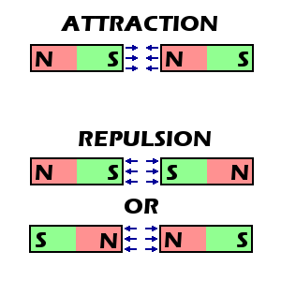 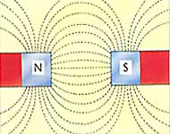

**Law of magnets**

Unlike poles attract each other and like poles repel each other.