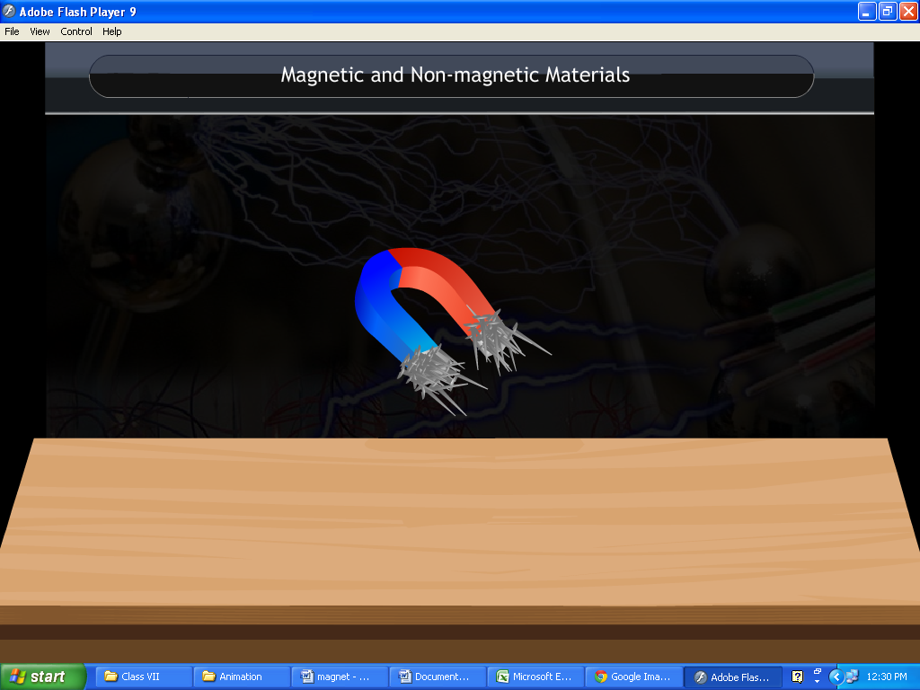**Magnetic and Non-magnetic Materials**

**Magnetic Materials**

* Materials that are attracted by a magnet are called magnetic materials.
* Objects made of materials such as iron; cobalt and nickel are magnetic objects.
* Examples of magnetic materials include iron nail, key, metal spade, needle and metal door handle.

**Non-Magnetic Materials**

* Materials that are not attracted by magnets are called non-magnetic materials.
* Modern coins are made of uniform mixtures of different metals so they become non- magnetic.
* Examples of non-magnetic materials include rubber, coins, feather and leather.

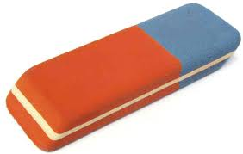 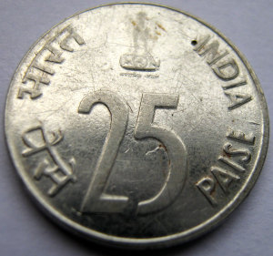

Coin

Rubber

**Types of magnets**

**Bar magnets:** In these magnets, the poles are located at the ends of the bar.

**Cylindrical magnets:** In these magnets, the poles are located at the two circular ends of the cylinder.

**Horseshoe magnets:** In these magnets, the poles are located at the two free ends of the 'U' shape.

**Dumb-bell shaped magnets:** In such magnets, the poles are located at the two dumb-bell shaped ends.

