Fun with Magnets

**How Magnets were discovered?**

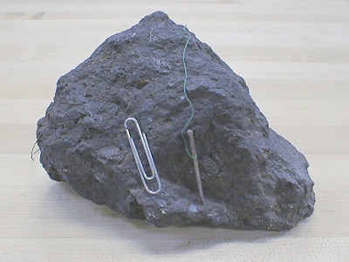A Greek shepherd named **Magnes** discovered magnets 4,000 years ago in Magnesia, Greece. The name **magnetite** has been derived from **Magnesia or Magnes**. Magnets are named after Magnetite.

Magnets attract magnetic materials. Natural rocks that have the property of attracting iron are called naturals magnets. Magnes discovered a natural magnetic rock, called the **lodestone.** In the form of a bar, it was used to find directions on the earth, and so the name, ‘lodestone,’ which means the stone that leads. Lodestone has a compound of iron called magnetite. These natural magnets have the magnetic property of attracting materials like iron.

Lodestone

**Artificial magnets**

Magnets can be made by man is called artificially magnets. A rectangular iron bar, an iron needle, a blade or an iron nail can be turned into a magnet by rubbing a bar magnet over it.