**Component of Food**

All food items contain various components that are essential for the proper growth and functioning of the body.

The components present in the food that are essential for the growth and development of the body are called **nutrients**.

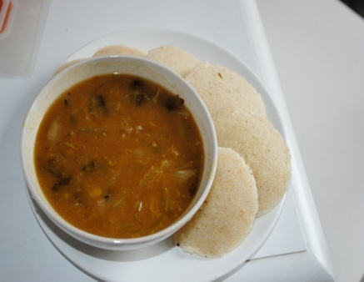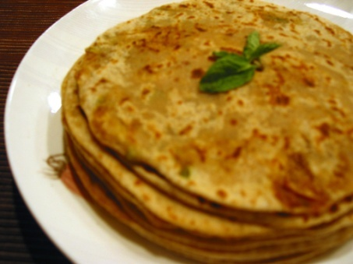 

The main nutrients are

**Carbohydrates**- It is a nutrient that is found in the food in the form of starch and sugar. Food item rich in carbohydrates are brown rice, white bread and potato.

**Proteins**- A nutrient that is required for the growth and repair of the body. For example pulses, peas, egg. They are also called as body building foods.

**Fats**- A nutrient which provides energy to carry out the various processes of the body. For example ghee, butter, chicken, pork.

**Vitamins**- These are required in very less amounts and helps in protecting our body against disease. There are several types of Vitamins like Vitamin A, B, C, D, E and K.

**Minerals**- Nutrients that are needed in small amount by our body for proper growth and to maintain good health. For e.g. calcium is a mineral found in milk.

**Roughage** - Roughage obtained from plants, is an essential component of our foods but do not contain any nutrient. This helps our body get rid of undigested foods. These are also called as dietary fibres.

**Balanced Diet**

A diet consisting of all the essential nutrients that our body needs in right proportion for proper growth is called as a **Balanced Diet**.

