**Food: Where Does It Come From?**

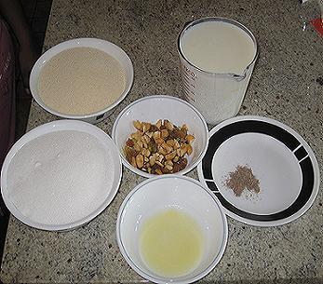

Ingredients are the food materials required to prepare a dish. For example to make *halwa* we need milk, suji, dry fruits, sugar, ghee and cinnamon powder.

**Food Materials and Sources**

* **Plant source**
* **Animal source**

The food items obtained from plants are called plant products. The vegetables, cereals, grains, wheat and rice all are plant products similarly food items obtained from animals like chicken, fish, prawns, pork, beef are called animals products. Milk which we drink is also an animal product that is further processed to make curd, paneer, cheese, ghee and butter.

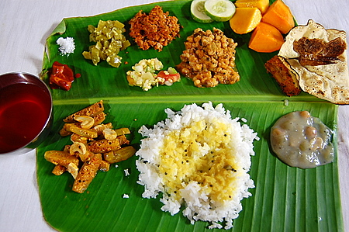 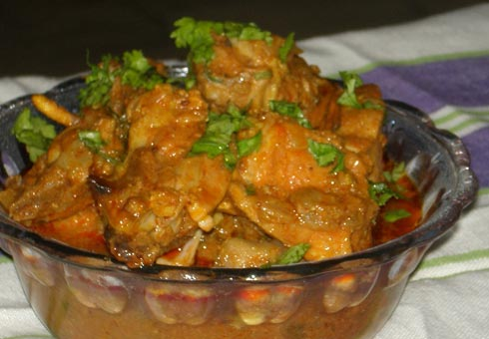

Plant products Animal products

**Plant Parts Products As Food**

It is surprising to know that we eat different parts of the plant in different food variety. For instance take the example of cabbage, a green leafly vegetable that most kids dislike to eat. It is the leaf of the plant that we eat.

Below is a table discussing the edible parts of various plants.

|  |  |
| --- | --- |
| **Leaves**  The leaves of spinach are eaten. Other e.g. are mustard and fenugreek. | [http://t2.gstatic.com/images?q=tbn:ANd9GcTM0k8QQ91IEWDilVLlaGnp9SJnNk0bM5xMuUFW843EqKfDCiZcaWaw1r0](http://www.google.co.in/imgres?imgurl=http://whatscookingamerica.net/SpinachHead.jpg&imgrefurl=http://whatscookingamerica.net/Spinach.htm&usg=__7ib02w-4EBVOpOTI17m3_BtmlyI=&h=333&w=350&sz=37&hl=en&start=1&zoom=1&tbnid=J7heqSHGU_oKLM:&tbnh=114&tbnw=120&ei=NuvzT5T3NoqqrAeP8czbBg&prev=/search?q=spinach&hl=en&gbv=2&tbm=isch&itbs=1)    Spinach |
| **Roots**  Carrot, radish and beetroot are the roots. | [http://t2.gstatic.com/images?q=tbn:ANd9GcQJTWVKg87tvwtLDfFDJUxsWiQen6jfluTJFdLmHLWlYsjKrhOsh37DHEP7](http://www.google.co.in/imgres?imgurl=http://zoebakes.com/wp-content/uploads/2008/04/carrot-cake01.jpg&imgrefurl=http://zoebakes.com/2008/04/27/the-ultimate-carrot-cake-with-cream-cheese-frosting-how-to-assemble-the-cake/&usg=__n5AwiupCCZZkfkgwBBmIx9rFr3k=&h=487&w=365&sz=80&hl=en&start=5&zoom=1&tbnid=EzhiAQKQJANWqM:&tbnh=129&tbnw=97&ei=tevzT4aaFMnPrQf-h73dBg&prev=/search?q=carrot&hl=en&gbv=2&tbm=isch&itbs=1)  Carrot |
| **Flower**  Flower of banana and pumpkin are the edible parts. | [http://t1.gstatic.com/images?q=tbn:ANd9GcS3GoMI5al8YN2RARfEgrlvK_QaxdpckZ27hOtfW1-XV-jLF_3YgITlyRs](http://www.google.co.in/imgres?imgurl=http://www.weego.in.th/ImgContent/S/BananaFlowerFull.jpg&imgrefurl=http://www.weego.in.th/service_products_detail.aspx?pd=WGS1100268&usg=__n6cQ1eHyQsYcvTetn5ObmpY4-M0=&h=400&w=285&sz=47&hl=en&start=1&zoom=1&tbnid=SeRl_fV9QlKaNM:&tbnh=124&tbnw=88&ei=-OvzT_GlHYfwrQfnwInFBg&prev=/search?q=flower+of+banana&hl=en&gbv=2&tbm=isch&itbs=1)    Banana |
| **Stem**  The sugarcane that is used to make sugar is the stem of the plant. Potato is also an underground stem called tuber. | http://agritech.tnau.ac.in/agriculture/CropProduction/Sugarcrops/sugarcrops_sugarcane_clip_image006_0002.jpg  Sugarcane |
| **Seeds**  The seeds of mustard are used for making vegetable oil. Other e.g. is soyabean. Black pepper is a seed used as a spice. | http://www.onlyfoods.net/wp-content/uploads/2012/06/Mustard-Seeds-Photos.jpg  Mustard seeds |
| **Fruit**  Apple, banana and mango are all eaten as fruit. | http://upload.wikimedia.org/wikipedia/commons/thumb/5/50/Mango_Bangladesh.JPG/220px-Mango_Bangladesh.JPG  Mango |

On the basis of the type of food they eat animals are divided into three categories.

These are

**Herbivore**- These animals eat only plants. Examples are cow, horse deer.

**Carnivore**- Animals which eat flesh of other animals are called carnivore. For e.g. lion, leopard, tiger etc.

**Omnivore**- These are the animals eat both plants as well as the animals like the crow and pigeon.

***********