**Food: Where Does It Come From?**

**Food Materials and Sources**

Now let us study what is the source of these food items?

The source of food items can be categorized into two parts.

The food items obtained from plants are called plant products. The vegetables, cereals, grains, wheat and rice all are plant products similarly food items obtained from animals like chicken, fish, prawns, pork, beef are called animals products. Milk which we drink is also a animal product that is further processed to make curd, paneer, cheese, ghee and butter.

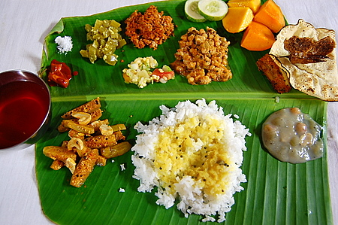 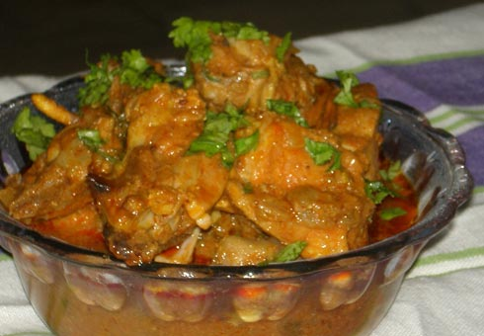

Plant products Animal products