**Food: Where Does It Come From?**

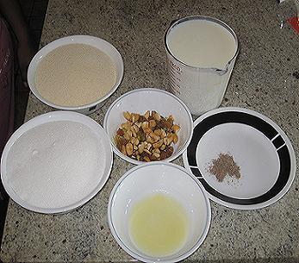**Food Variety**

You must have observed all of the students in your class bring different variety of food. For instance, one student brings chapatti and paneer curry while other brings rice and fish curry or halwa.

Have you wondered what are the ingredients required to prepare these food items? But first let us become familiar with the term ingredients.

These are the ingredients required to make *halwa*.

Ingredients are the food materials required to prepare a dish. For example to make *halwa* we need milk, suji, dry fruits, sugar, ghee and cinnamon powder.