**MATRIX**

**Question 1**

In the following question, a word is represented by only one set of numbers as given in any one of the alternatives. The set of numbers given in the alternatives is represented by two classes of alphabets as in two matrices given below. The columns and rows of Matrix-I are numbered from 7 to 10 and that of Matrix-II from 2 to 6. A letter from these matrices can be represented first by its row and then by its column, example, ‘D’ can be written as 23 and 32.

Identify the set for the word DOSSIER.

Matrix - I Matrix - II

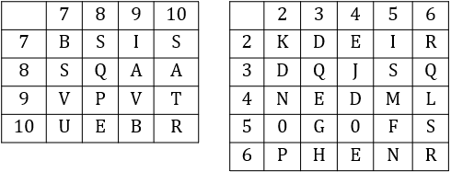

A. 23, 54, 710, 25, 66, 26, 36

B. 32, 35, 56, 44, 25, 78, 52

C. 23, 43, 66, 26, 54, 35, 56

D. 32, 54, 710, 87, 25, 24, 66

Answer: D

**Question 2**

In the following question, a word is represented by only one set of numbers as given in any one of the alternatives. The set of numbers given in the alternatives is represented by two classes of alphabet as in two matrices given below. The columns and rows of Matrix I are numbered from 7 to 10 and that of Matrix II from 2 to 6. A letter from these matrices can be represented first by its row and then by its column, for example, ‘D’ can be written as 23 and 32.

Identify the set for the word RISE.

Matrix - I Matrix - II



A. 1010, 25, 35, 24

B. 26, 79, 87, 66

C. 26, 79, 99, 36

D. 66, 89, 32, 64

Answer: A

**Question 3**

In the following question, a word is represented by only one set of numbers as given in any one of the alternatives. The set of numbers given in the alternatives are represented by two classes of alphabet as in two matrices given below. The columns and rows of Matrix I are numbered 0 to and that of Matrix II are numbered 5 to 9. A letter from these matrices can be represented first by its row and then by its column, for example, C can be represented by 55, 69 etc. and D can be represented by 59, 68 etc.

Similarly, you have to identify the set for the word given in the question. ROUND

Matrix - I Matrix - II

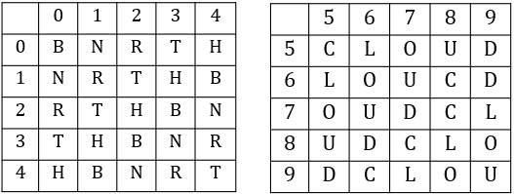

A. 02, 57, 67, 23, 95

B. 34, 66, 58, 33, 95

C. 20, 56, 99, 33, 77

D. 11, 75, 59, 42, 86

Answer: B

**Question 4**

A word is represented by only one set of numbers as given in any one of the alternatives. The sets of numbers given in the alternatives are represented by two dasses of alphabets as shown in the given two matrices. The columns and rows of Matrix-I are numbered from 0 to 4 and that of Matrix-II are numbered from 5 to 9. A letter from these matrices can be represented first by its row and next by column, for example, 'D' can be represented by 11, 42 etc., and 'D' can be represented by 68, 99, etc.

Similarly, you have to identify the set for the word "NOSE".

Matrix - I Matrix - II

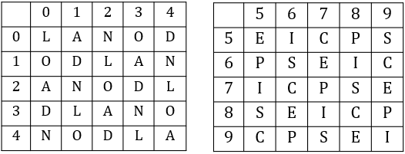

A. 21, 10, 78, 98

B. 13, 22, 66, 56

C. 02, 34, 59, 68

D. 41, 42, 85, 86

Answer: A

**Question 5**

A word is represented by only one set of numbers as given in any one of the alternatives. The sets of numbers given in the alternatives are represented by two dasses of alphabets as shown in the given two matrices. The columns and rows of Matrix-I are numbered from 0 to 4 and that of Matrix-II are numbered from 5 to 9. A letter from these matrices can be represented first by its column, for example, 'E' can be represented by 11, 42, etc., and 'F' can be represented by 65, 88, etc.,

Similarly, you have to identify the set for the word "GRAND".

Matrix - I Matrix - II

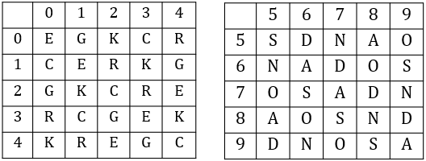

A. 01, 12, 58, 65, 56

B. 43, 41, 85, 88, 98

C. 20, 23, 66, 95, 89

D. 14, 04, 99, 57, 68

Answer: A

**Question 6**

A word is represented by only one set of numbers as given in any one of the alternatives. The set of numbers given in the alternatives are represented by two classes of alphabets as in two matrices given below. The columns and rows of Matrix I are numbered from 0 to 4 and that of Matrix II are numbed from 5 to 9. A letter from these matrices can be represented first by its row and next by its column, e.g., A can be represented by 02, 11 etc., and L can be represented by 56, 67 etc.

Similarly, you have to identify the set for the word BEARD.

Matrix - I Matrix - II

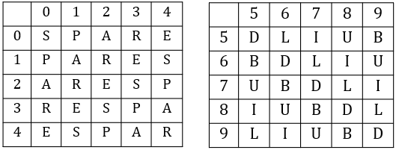

A. 87, 13, 43, 21, 88

B. 88, 13, 43, 44, 21

C. 88, 87, 43, 21, 13

D. 87, 13, 43, 88, 21

Answer: A

**Question 7**

A word is represented by only one set of numbers as given in any one of the alternatives. The sets of numbers given in the alternatives are represented by two classes of alphabets as shown in the given two matrices. The columns and rows of Matrix-I are numbered from 0 to 4 and that Matrix-II are numbered from 5 to 9. A letter from these matrices can be represented first by its row and next by its column, for example, 'Y' can be represented by 00, 22, etc., and 'U' can be represented by 42, 59, etc.

Similarly, you have to identify the set for the word "PARK".

Matrix - I Matrix - II

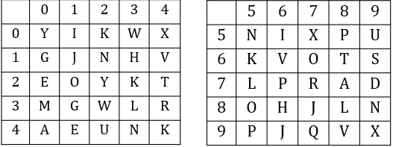

A. 58, 40, 86, 34

B. 76, 55, 89, 23

C. 23, 78, 34, 02

D. 95, 40, 77, 65

Answer: D

**Question 8**

A word is represented by only one set of numbers as given in any one of the alternatives. The sets of numbers given in the alternatives are represented by two classes of alphabets as shown in the given two matrices. The columns and rows of Matrix-I are numbered from 0 to 4 and that of Matrix-II are numbered from 5 to 9. A letter from these matrices can be represented first by its row and next by its column, for example 'C' can be represented by 21,34 etc and T can be represented by 97,89 etc.

Similarly, you have to identify the set for the word 'MAZE’.

Matrix - I Matrix - II

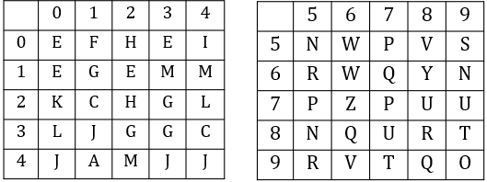

A. 22,97,43,66

B. 24,76,12,66

C. 31,76,11,58

D. 14,41,76,12

Answer: D

**Question 9**

A word is represented by only one set of numbers as given in any one of the alternatives. The sets of numbers given in the alternatives are represented by two lasses of alphabets as shown in the given two matrices. The columns and rows of Matrix-I, are numbered from 0 to 4 and that of Matrix-II are numbered from S to 9. A letter from these matrices can be represented first by its row and next by its column, for example 'A' can be represented by 31, 43 etc and 'U' can be represented by 85, 96 etc.

Similarly, you have to identify the set for the word 'SINE'.

Matrix - I Matrix - II

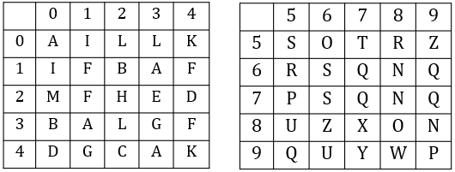

A. 21,99,31,85

B. 12,87,11,78

C. 31,65,14,76

D. 76,10,68,23

Answer: D

**Question 10**

A word is represented by only one set of numbers as given in any one of the alternatives. The sets of numbers given in the alternatives are represented by two classes of alphabets as shown in the given two matrices. The columns and rows of Matrix•I are numbered from 0 to 4 and that of Matrix•II are numbered from 5 to 9. A letter from these matrices can be represented first by its row and next by its column, for example 'A' can be represented by 31, 23 etc and 'P' can be represented by 86, 97 etc.

Similarly, you have to identify the set for the word 'KILT'.

Matrix - I Matrix - II

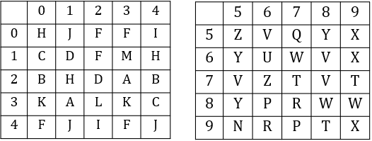

A. 33,86,33,78

B. 14,58,22,56

C. 30,42,32,77

D. 21,79,42,97

Answer: C