1. Identify the number at the bottom when the top is 5 in a dice.

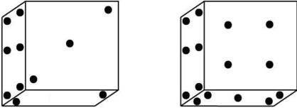

1. 2
2. 3
3. 4
4. 6
5. Two positions of a dice are shown below. When three is at the top what number will be at the bottom?

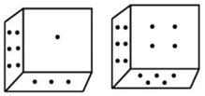

1. 2
2. 1
3. 4
4. 5
5. Three positions of a dice are given. Find out which number is found opposite the number 2 in the given cube.

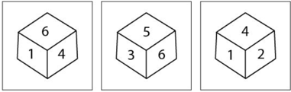

1. 6
2. 5
3. 3
4. 1
5. Four positions of dice are below. Which letter will be opposite to D?

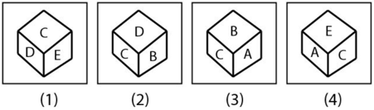

1. B
2. C
3. D
4. A
5. Four positions of a dice are given below. Identify the number at the bottom when top is 1.

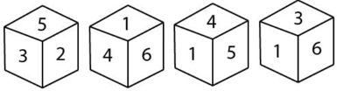

1. 6
2. 3
3. 2
4. 5
5. Four positions of a dice are given below. Identify the number at the when the number on the top is 2.

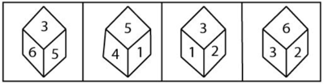

1. 6
2. 3
3. 4
4. 5
5. Four different views of a cube / dice are given as viewed from different angles. Find out the number of dots on the face opposite to the face with one dot.

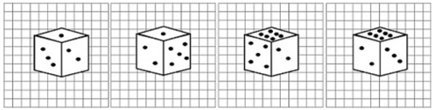

1. 6
2. 5
3. 4
4. 3
5. In the diagrams below, faces of dice are shown from two different directions. Which number will be opposite to 4?

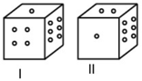

1. 2
2. 3
3. 4
4. 5
5. Two positions of the same dice are given. Which number will be at the bottom if ‘4’ is at the top?

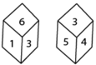

1. 3
2. 2
3. 6
4. 1
5. Two positions of a dice are shown below. When there are five dots at the top, how many dots will be at the bottom?

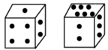

1. 2
2. 6
3. 1
4. 3
5. From the given options, which answer figure can be formed by folding the given in the questions?

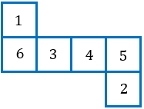

1. 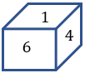
2. 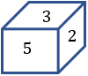
3. 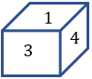
4. 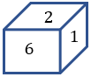
5. A paper sheet is made into the following pattern (A). find the cube that will best represent after folding the paper (A).

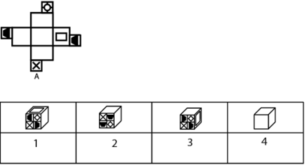

1. 1, 2 and 3 only
2. 1, 3 and 4 only
3. 2, 3 and 4 only
4. 2 and 3 only
5. Four different positions of the same dice are shown. Find the number on the face opposite to the one having 3.

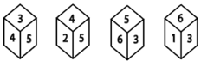

1. 2
2. 4
3. 1
4. 6
5. Which of the following cubes can be created by folding the given figure?



1. 
2. 
3. 
4. 
5. If the following is folder to form a cube, then which number will on the face opposite to the face having number ‘1’?

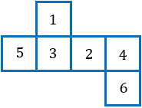

1. 5
2. 4
3. 1
4. 6
5. The expanded from of a dice is given below. If it is changed to a dice after folding, then which dice can be formed?

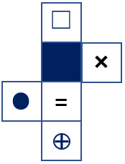

1. 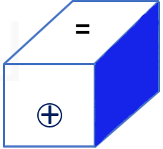
2. 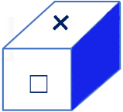
3. 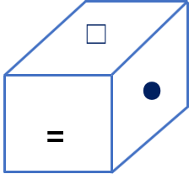
4. 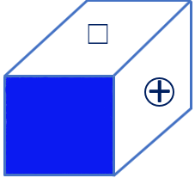
5. Which of the cubes from the given option can be made from the given sheet of paper?

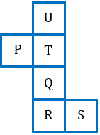

1. 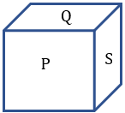
2. 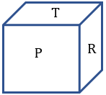
3. 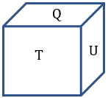
4. 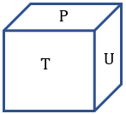
5. Possible combinations of die.

Observe the open die

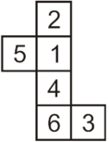

The number of a possible combination is:

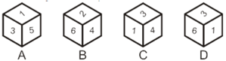

1. Only A
2. Only B
3. Only C
4. Only D
5. Finding the opposite side.

Observe the die

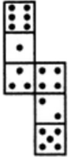

If the surfaces of the above die are reconstructed to from a perfect die. How many dots having three dots?

1. 2
2. 4
3. 5
4. 6
5. Choose the die that is similar to the die, formed from the open die.

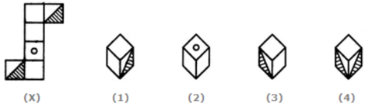

1. Only 1
2. Only 2
3. 1 and 3
4. 1, 2 and 3

Completion of Figure

