MATHEMATICS
VISUALISING SOLID SHAPES

1 The net of a solid consists of three rectangles and two triangles. This may be the net of a:

(A) Cuboid (B) Pyramid (C) Triangular Prism (D) None of these

ANS . C

2 A rectangular pyramid has:

(A) 2 faces (B) 4 faces (C) 5 faces (D) 6 faces

ANS . C

3 The other name of a tetrahedron is:

(A) Triangular Pyramid (B) Triangular Prism
(C) Square Pyramid (D) None of these

ANS . A

4 A square prism has:

(A) 5 edges (B) 8 edges (C) 12 edges (D) 15 edges

ANS . C

5 Circle is a:

(A) Plane figure (B) Solid figure (C) Both (A) and (B) (D) None of these

ANS . A

6 The net for a cylinder without top and bottom is a:

(A) Rectangle (B) Circle (C) Triangle (D) None of these

ANS . A

7 A cone has:

(A) 1 face (B) 2 faces (C) 3 faces (D) 5 faces
ANS . B

8 The name of the figure which has 6 vertices, 9 edges and 5 faces is:

(A) Cuboid (B) Cube (C) Cone (D) Triangular Prism

ANS . D

9 Name the solid figure which has no vertex and no edge:

(A) Cylinder (B) Cone (C) Sphere (D) Tetrahedron

ANS . C

10 A petagonal pyramid has:

(A) 3 vertices (B) 4 vertices (C) 6 vertices (D) None of these

ANS . C

11 A line where two faces of a solid meet is called its __________

(A) Face (B) Edge (C) Vertex (D) None of these

ANS . B

12 A square pyramid has __________ triangular faces.

(A) 4 (B) 3 (C) 2 (D) 1

ANS . A

13 A cube has __________ vertices and __________ surfaces.

(A) 6, 3 (B) 8, 4 (C) 8, 6 (D) 7, 5

ANS . C
14 Number of vertices in a cone is :

(A) 1 (B) 2 (C) 0 (D) None of these

ANS . A
15 Shape of the base of tetrahedron is

(A) Triangular (B) Square (C) Rectangle (D) Circular

ANS . A

16 Using Euler's formula find the number of faces in a polyhedron having 6 vertices and 12 edges?

(A) 6 (B) 7 (C) 8 (D) 9

ANS . C

17 The figure shows a solid.

Which of the following is
net of the solid?
(A) (B) (C) (D)

ANS . C

18 Which of the following is 3-d figure?

(A) Rectangle (B) Cylinder (C) Circle (D) Octagon

ANS . B

19 The figure shows a solid.

Which of the following is a
net of the solid?
(A) (B) Q.9 The figure shows a solid.

Which of the following is a net of the solid?
(A) (B) (C) (D)

ANS . D

20 The name of the solid shape is
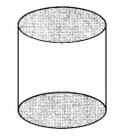
(A) cone (B) cylinder (C) sphere (D) cube
ANS : (B) cylinder

21 The name of the solid shape is
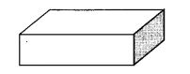
(A) cuboid (B) cube (C) pyramid (D) cone
ANS : (A) cuboid

22 The name of the solid shape is
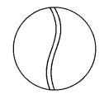
(A) cylinder (B) cone (C) sphere (D) cube

ANS : (C) sphere

23 The name of the solid shape is
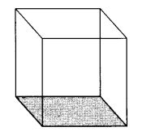
(A) cube (B) cylinder (C) cone (D) sphere
ANS : (A) cube

24 The name of the solid shape is
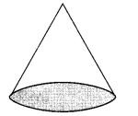
(A) cylinder (B) cone (C) cuboid (D) sphere
ANS : (B) cone

25 The name of the solid shape is
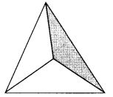
(A) cylinder (B) cone (C) sphere (D) pyramid
ANS : (D) pyramid

26 The number of vertices of a cube is
(A) 8 (B) 12 (C) 6 (D) 3
Answer: (A) 8

27 The number of edges of a cube is
(A) 8 (B) 12 (C) 6 (D) 3
ANS : (B) 12

28 The number of faces of a cube is
(A) 8 (B) 12 (C) 6 (D) 3
ANS: (C) 6

29 The number of vertices of the solid shape is
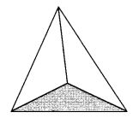
(A) 1 (B) 2 (C) 3 (D) 4
ANS : (D) 4

30 The number of faces of the solid shape is
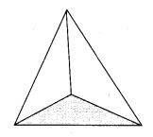
(A) 1 (B) 2 (C) 3 (D) 4
ANS : (D) 4

31 The number of edges of the solid shape is
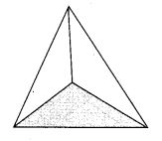
(A) 1 (B) 2 (C) 3 (D) 6
ANS : (D) 6

32 The number of vertices of the solid shape is
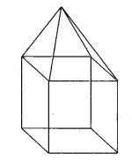
(A) 9 (B) 4 (C) 6 (D) 8
ANS : (A) 9

33 The number of faces of the solid shape is
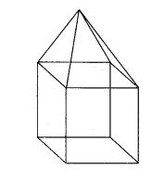
(A) 4 (B) 6 (C) 9 (D) 8
ANS : (C) 9

34 The number of edges of the solid shape is
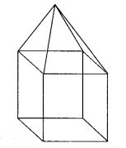
(A) 16 (B) 9 (C) 6 (D) 4
ANS : (A) 16

35 Two cubes of edge length 2 cm are placed side by side. The length of the resulting cuboid is
(A) 2 cm (B) 4 cm (C) 1 cm (D) none of these
ANS : (B) 4 cm

36 What cross-section do you get when you give a horizontal cut to a die?
(A) Square (B) Rectangle C) Triangle (D) Circle
ANS : (A) Square

37 What cross-section do you get when you give a vertical cut to a brick?
(A) Square (B) Rectangle (C) Triangle D) Circle
ANS : (A) Square

38 What cross-section do you get when you give a horizontal cut to a brick?
(A) Triangle (B) Circle (C) Square (D) Rectangle
ANS : (D) Rectangle

39 What cross-section do you get when you give a vertical cut to a round apple?
A) Circle (B) Triangle (C) Square (D) Rectangle
ANS : (A) Circle

40 What cross-section do you get when you give a horizontal cut to a round apple?
(A) Circle (B) Square (C) Rectangle (D) Triangle
ANS : (A) Circle

41 What cross-section do you get when you give a vertical cut to an ice-cream cone?
(A) Triangle (B) Circle (C) Rectangle (D) Square
ANS : (A) Triangle

42 What cross-section do you get when you give a horizontal cut to an ice-cream cone?
(A) Triangle (B) Circle (C) Rectangle (D) Square
ANS : (B) Circle

43 The shadow of the lamp of an a cube when seen under overhead projector is
(A) square (B) circle (C) triangle (D) rectangle
ANS : (A) square

44 The number of faces of a rectangular prism is _______.
(A) 4 (B) 6 (C) 3 (D) None of these
ANS : (B) 6

45 Opposite faces of at die always have a total of dots on them :
(A) 6 (B) 5 (C) 7 (D) None of these
ANS : (C) 7
Observe a die and see.

46 The number of edges of a square pyramid is _______.
(A) 4 (B) 6 (C) 8 (D) None of these
ANS : (C) 8

47 The number of faces of a triangular pyramid or tetrahedron is _______.
(A) 4 (B) 6 (C) 5 (D) 1024
ANS : (A) 4

48 Three cubes each with 2 cm edge are placed side by side to form a cuboid. Its length will be :
(A) 4 cm (B) 2 cm (C) 6 cm (D) None of these
ANS : (C) 6 cm
Each cube has one side 2 cm, therefore sum of three sides is 6 cm.

49 The number of triangular faces of a triangular prism is _______.
(A) 2 (B) 1 (C) 4 (D) None of these
ANS : (A) 2

50 Which of the following is the number of vertices of sphere?
(A) 0 (B) 1 (C) 2 (D) 4
ANS : (A) 0

51. There are _________.. edges in a cube.
(A) 8 (B) 12 (C) 4 (D) None of these
ANS : (B) 12
There are 12 line segments that form the skelton of the cube.

52 A die is cut horizontally. What is the cross-section obtained?
(A) A triangle (B) A rectangle (C) A square (D) A cube
ANS : (C) A square

53 The number of faces of a cube is _______.
(A) 4 (B) 6 (C) 8 (D) None of these
ANS : (B) 6

54 If two cubes of dimensions 2 cm by 2 cm are placed side by side, what would the dimensions of resulting cuboid be ?
(A) 4, 2, 2 (B) 2, 4, 2 (C) 2, 2, 4 (D) Noun of these
ANS : (A) 4, 2, 2
When two cubes are kept side by side the length is the only measurement which increases, it becomes 2 + 2 = 4 cm.
The breadth = 2, cm and the height = 2 cm.

55 The number of faces of a triangular prism is _______.
(A) 5 (B) 6 (C) 4 (D) None of these
ANS : (C) 4

56. There are ____________ faces in a cube.
(A) 8 (B) 4 (C) 6 (D) None of these
ANS : (C) 6
The six flat square surfaces that are the skin of the cube.

57 Cuboid is an example of
(A) Both (B) 2-D shape (C) 3-D shape (D) None of these
ANS : (C) 3-D shape

58 The vertical cut of a brick will show the cross section is
(A) circle (B) pentagon (C) rectangle (D) hexagon
ANS : (C) rectangle
59 There are _________. vertices in a cube.
(A) 8 (B) 6 (C) 4 (D) None of these
ANS : (A) 8
There are 8 vertices of the cube.

60 The number of edges of a rectangular pyramid is _______.
(A) 21 (B) 8 (C) 7 (D) None of these
ANS : (B) 8

61. The number of edges of a triangular pyramid is _______.
(A) 8 (B) 5 (C) 6 (D) None of these
ANS : (C) 6

62 Three dimensional shapes have :
(A) length, breadth, height (B) length, breadth
(C) breadth height (D) None of these
ANS : (A) length, breadth, height
Which occupy space and have three demensions.

63 A cuboid has ________ rectangular faces.
(A) 8 (B) 2 (C) 6 (D) 4
ANS : (C) 6

64 Identify the correct statement from the following.
(A) A triangle has 3 sides and 4 vertices.
(B) A cylinder has 3 faces.
(C) All sides of the rectangle are equal.
(D) A cuboid has 4 flat faces and 12 straight edges.
ANS : (B) A cylinder has 3 faces.

65 The number of faces of a square pyramid is _______.
(A) 4 (B) 7 (C) 5 (D) None of these
ANS : (C) 5

66 Rakesh has 10 one rupee coins of similar kind. He puts them exactly one on the other. What shape will he get finally?
(A) Circle (B) Cylinder (C) Cube (D) Cone
ANS : (B) Cylinder

67 The number of faces of a cylinder is _______.
(A) 2 (B) 1 (C) 3 (D) None of these
ANS : (A) 2

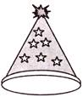
69. The given figure shows a party cap. What is the cross - section obtained when a horizontal cut parallel to base, is given to the cap?
A) Circle B) SquareC) Triangle D) Rectangle
ANS : A

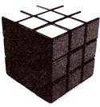
70. The given figure shows a Rubik's cube. It is a source of famous puzzle in the form of a cube with 9 squares on each side, and each side of a different colour. What is the cross - section obtained when a vertical cut is given to the Rubik's cube?
A) Circle B) Square
C) Triangle D) Rectangle
ANS : B

71. Which of the following nets cannot be used to form a cube?

A) 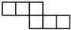 B) 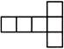 C) 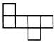 D) 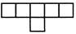
ANS : D

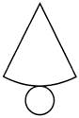
72. Which three - dimensional figure can be obtained from the given net?

A) Cone B) Cylinder

C) Triangular prism D) Triangular pyramid
ANS : A

73. Which row is matched incorrectly?
Row | Three-Dimensional Figure | Horizontal / Vertical Cut | Cross- section Obtained
I |  | Horizontal | Circle
II |  | Vertical cut parallel to front face | Rectangle
III | 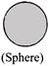 | Vertical | Circle
IV | 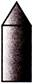 | Vertical cut parallel to Rectangle front face | Rectangle

A) row I B) row II C) row III D) row IV
ANS : D

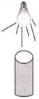
74. The given figure shows a bulb that is kept just above a can of soft drink. What is the shape of the shadow of the can?

A) Rectangle

B) Circle

C) Square

D) Triangle
ANS : B

75. The number of cubes in figure below is: 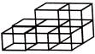

A) 7

B) 8

C) 9

D) 10
ANS : B

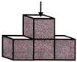
76. What is the view of the solid shown in the given figure as seen from the direction indicated by the arrow?

A) 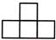 B)

C) D) 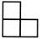
ANS: C

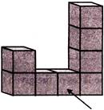
77. What is the view of the solid shown in the given figure as seen from the direction indicated by the arrow?

A) B) 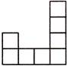

C) D)

ANS : B

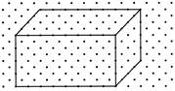
78. The given figure shows a cuboid drawn on the isometric dot sheet. How many cubes, each having a side of length 4 units, can be formed by cutting the given cuboid?

A) 1 B) 2

C) 3 D) 4
ANS : B

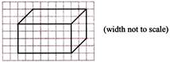
79. The given figure shows the oblique sketch of a cuboid that has a width of 5 units. What is the sum of the areas of the faces of the given cuboid?

A) 83 square units B) 166 square units

C) 225 square units D) 332 square units
ANS : B

80. The given figure shows an isometric sketch of a three - dimensional
figure.
Which oblique sketch correctly represents the given figure?

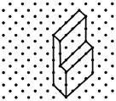
A) 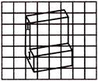

B) 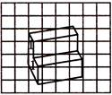

C) 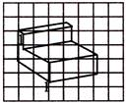

D) 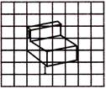

ANS : B
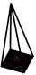

81. How many edges does the following figure have?

A) 5 B) 8 C) 10 D) 11

ANS : B

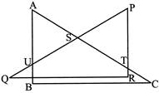
82. How many triangles can be seen in this figure?

A) 3 B) 5 C) 6 D) 7
ANS : B

83. Which of the following figures has six faces?

A) B) 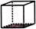 C) 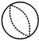 D) 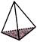
ANS : B

84. Which of the following is different from the other three?

A) 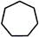 B) 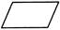 C) D) 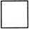
ANS : A

85. Which of the following pair of shapes, when joined together (by placing them edge to edge) can from a rectangle?

A) 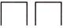 B) 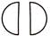 C) 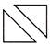 D) 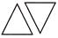
ANS : C

86. A solid object when seen from one side, looks like this.

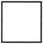

The same solid, when viewed from top, looks like this.

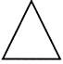

Which of these shapes could it be?

A) 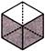 B) 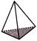 C) 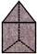 D) 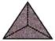
ANS : C

87. Identify the correct statement from the following.
A) A triangle has 4 sides, three faces and 3 vertices.
B) A cylinder has 3 faces.
C) All sides of cuboid are equal.
D) A cuboid has 4 flat faces and 12 straight edges.
ANS : B
88. Ashok has 10 one rupee coins of similar kind. He puts them exactly one on the other. What shape will he get finally?
A) Circle B) Cylinder C) Cube D) Cone
ANS : B

89. Match the following.
 | Column-I |  | Column-II
(i) | 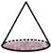 | (A) | 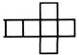
(ii) | 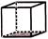 | (B) | 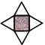
(iii) | 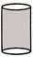 | (C) | 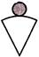
(iv) | 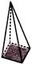 | (D)

A) (i) - (A), (ii) - (B), (iii) - (C), (iv) - (D)

B) (i) - (C), (ii) - (A), (iii) - (D), (iv) - (B)

C) (i) - (C), (ii) - (B), (iii) - (A), (iv) - (D)

D) (i) - (D), (ii) - (A), (iii) - (C), (iv) - (B)
ANS : B
90. Identify the false statement from the following.
A) A cuboid has 3 pairs of opposite faces.
B) The number of vertices of a cube is 6.
C) All sides of a square are equal.
D) A square pyramid is a three-dimensional figure.
ANS : B

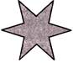
91. How many corners does the shape given have?

A) 8 B) 9 C) 12 D) 11
ANS : C
92. What is the number on the face opposite to 4 on a die?
A) 0 B) 3 C) 2 D) 1
ANS : B

93. If front view of a solid is

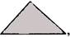

then what could be the

shape of the solid?

A) A die B) A match box C) A pyramid D) A ball
ANS : C

94. The front, side and top views of

an object is as shown.

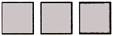

Identify the possible object.

A) 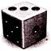 B) 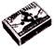 C) 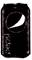 D) 
ANS : A

95. Observe the object given.

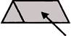

What is its side view

indicated by the arrow?

A) B) C) 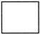 D) 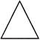
ANS : A

96. Identify the number of vertices of the given solid. 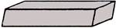

A) 8 B) 6 C) 12 D) 10
ANS : A

97. Identify the cross - section of the given solid at the dotted line. 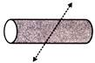

A) 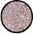 B) 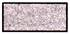 C) 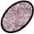 D) 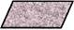
ANS : C

98. A hollow pipe is viewed from the side indicated by the arrow. What is the shadow obtained? 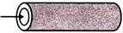

A) A ring B) A circle C) A cylinder D) An ellipse
ANS : A

99. Identify the solid which has the following views. 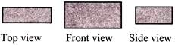 A) A cube B) A cuboid C) A cone D) A sphere
ANS : B

100. The following arrangement of cubes is painted on all sides. 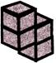 How many square faces are painted?

A) 16 B) 9 C) 18 D) 12
ANS : C

