**Chapter-7 FOOD**

***Food from plants***

(1) Food helps us to_________ .

(a)healthy (b) Grow

(c) get energy (d) all of these

(2) we eat fruits such as ___________ .

(a) apple (b) mango

(c) grapes (d) all of these

(3) We need _______ to work and play.

(a) team (b) car

(c) Energy (d) family

(4) _______ gives us energy.

(a) food (b) cycle

(c) cartoons (d) book

(5) We get food from _________ .

(a) plants (b) animals

(c) both (a) and (b) (d) wood

(6) Plants give us ________ .

(a) fruits (b) vegetables

(c) both (a) and (b) (d) egg

(7) Fruits and vegetables keep us_______.

(a) healthy and fit (b) unhealthy

(c) weak (d) careless

(8) Plants give us ________ .

(a) cereals (b) ghee

(c) milk (d) butter

(9) Wheat, rice and maize are called_________ .

(a) cereals (b) pulses

(c) vegetables (d) fruits

(10) Gram, chickpea, kidney beans etc. are called________ .

(a) fruits (b) vegetables

(c) pulses (d) cereals

(11) Fruits and vegetables protect us from________.

(a) virus (b) mosquito

(c) diseases (d) animals

(12) We should drink plenty of _____________________.

(a) water (b) juice

(c) tea (d) coffee

(13) Wheat is a _____________________.

(a) vegetable (b) fruit

(c) pulses (d) cereals

(14) Junk food is ________ for our health.

(a) good (b) nice

(c) healthy (d) unhealthy

(15) Plants give us __________.

(a) egg (b) pulses

(c) milk (d) meat

***Food from Animals***

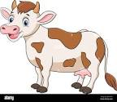(1) We get milk from ________ .

(a) Hen (b) Cow

(c) Fruit (d) Plant

(2) __________are made from milk.

(a) ghee (b) curd

(c) both (a) and (b) (d) none of these

(3) Things like ghee, curd, cheese, butter etc. are made from _________

(a) milk (b) wheat

(c) maize (d) rice

(4) We get eggs and meat from________

(a) animals (b) plants

(c) both a and b (d) cant’say

(5) We get ___________ from animals.

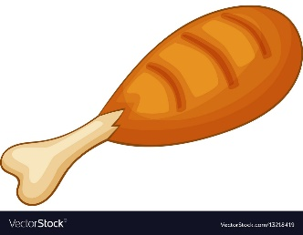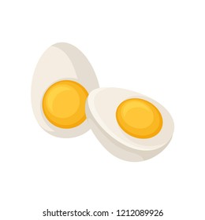(a) (b)

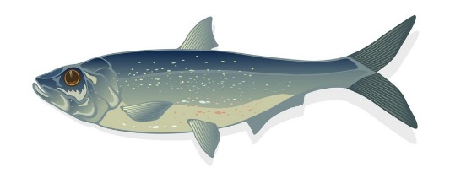

(c) (d) all of these

(6) We eat food to grow.

(a) get energy (b) healthy

(c) strong (d) all of these

(7) We should eat _________ food.

(a) healthy (b) waste

(c) junk food (d) all of these

(8) _________ helps in the growth of your body

(a) Fish (b) burger

(c) noodles (d) cake

(9) we should eat following to remain fit:

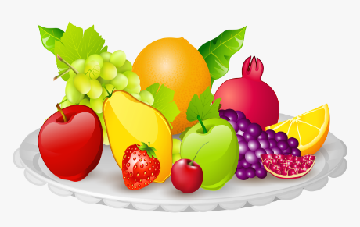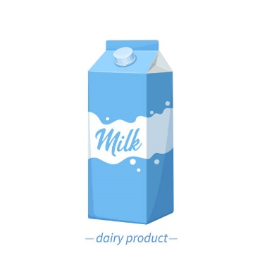

(a) (b)

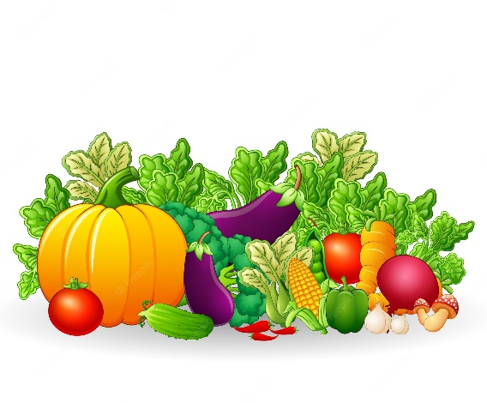(c)

(d) all of these

(10) Which of the following are not food items?

(a) icecream (b) pastry

(c) smart phone (d) choclates

(11) We get honey from…….

(a) cow (b) Bee

(c) Goat (d) Hen

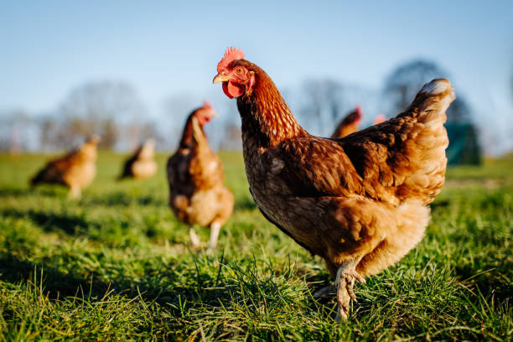

(12) See The picture and tell this animal gives us

(a) egg (b) honey

(c) milk (d) curd

(13) Can you name the fruit which is called by its colour

(a) banana (b) orange

(c) grapes (d) apple

(14) Children should drink a glass of milk …………..?

(a) daily (b) sometimes

(c) in a week (d) don’t drink

(15) we should wash our ________ before eating.

(a) hands (b) hair

(c) stomach (d) toes