**Chapter-5 Road safety**

**Lecture-2 Traffic lights**

(1) The traffic lights are for the safety of the________ .

(a) People (b) traffic.

(c) children (d) policeman

(2) How many lights are there in Traffic single?

(a) one (b) four

(c) five (d) three

(3) When lights turns red, you should?

(a)Walk (b)Ready to go

(c) Stop (d) Wait

(4) When traffic light turns yellow, you should_____ . <img src="4_Q.gif" >

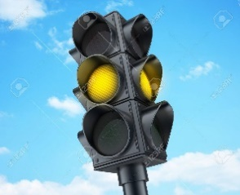(a) Stop (b)Run

(c) Walk (d)wait and get ready to go

(5) When traffic light turns green, you should_____ .

(a) Go (b) Walk

(c) Stop (d) Wait

(6) The traffic on the road is controlled by the and the?

(a) traffic lights (b) traffic police

(c) both(a) and (b) (d) none of these

(7) We should________ the traffic rules.

(a) Obey (b) regret

(c) disobey (d) not following

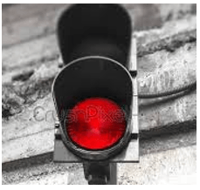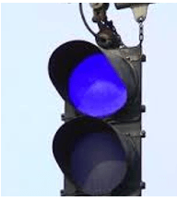(8) Which of the following light blinks, when we need to stop at a traffic signal?

(a) (b)

(c) (d)

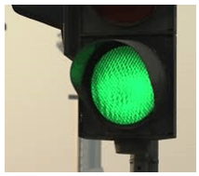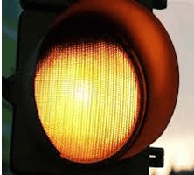

(9) Is it good to help people to cross the road?

(a) yes (b) no

(c) as your wish (d) can’t say

(10) Traffic moves when the traffic light indicates______ colour.

(a) Red (b) Green

(c) Blue (d) Yellow

(11) The traffic get ready to move when the traffic light indicates______colour.

(a) Red (b) Green

(c) Blue (d) yellow

(12) Why should we follow safety rules ?

(a) To avoid accident (b) to take rest

(c) To avoid rush (d) to feel happy

(13) When crossing at the traffic lights, what should you wait for?

(a) The purple lady (b) the blue lady

(c) the red man (d) the green man

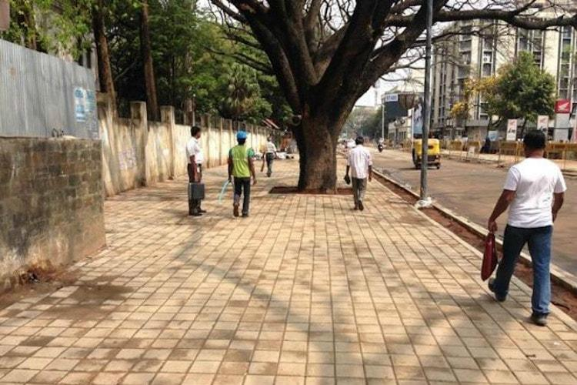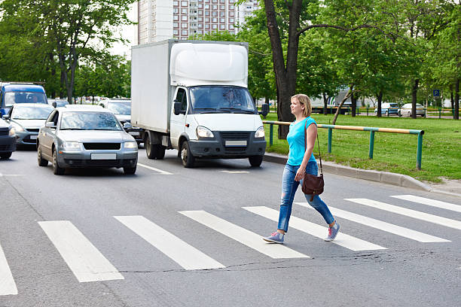(14) Always cross the road at the……..

(a) (b)

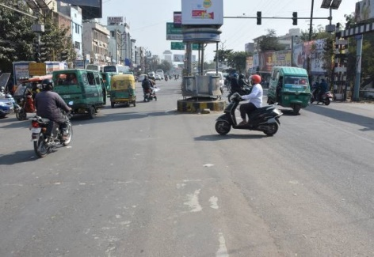(c) (d)

(15) Is it safe for you to cross the road alone?

(a) yes (b) No

(c) sometimes (d) with elders