Class II_Science
Class_II_Our Environment_ Activity 6_take pop for puzzle

The World of Plants
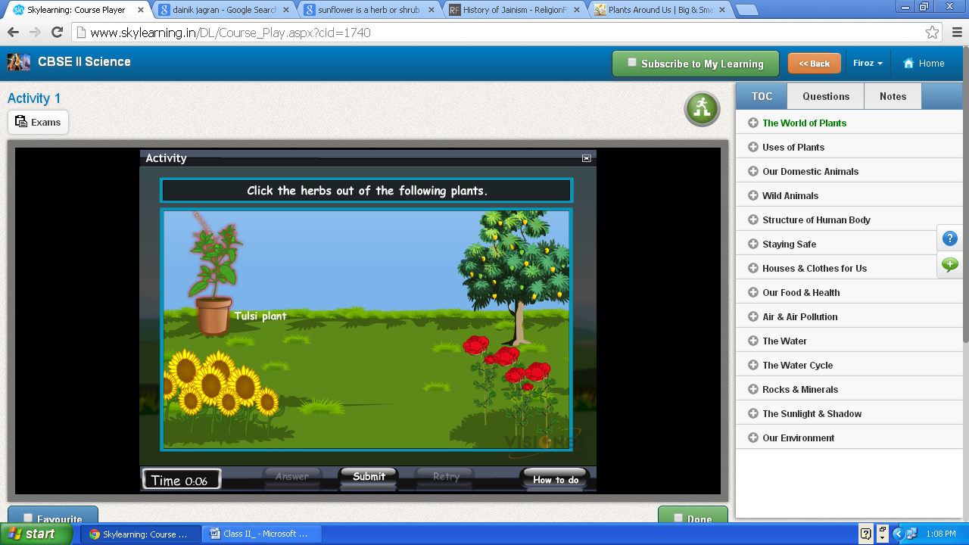
Mint
Correct answer
Grass, mint, wheat, sunflower, lady’s finger, etc., are herbs.
Rose, tulsi, jasmine, hibiscus, etc., are shrubs.

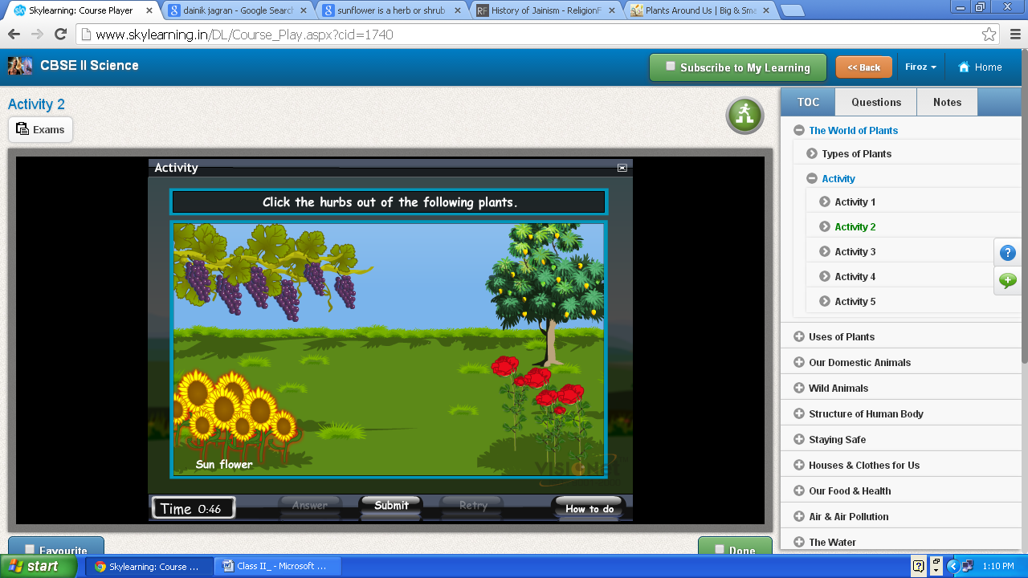
Rose
Shrubs
Mint

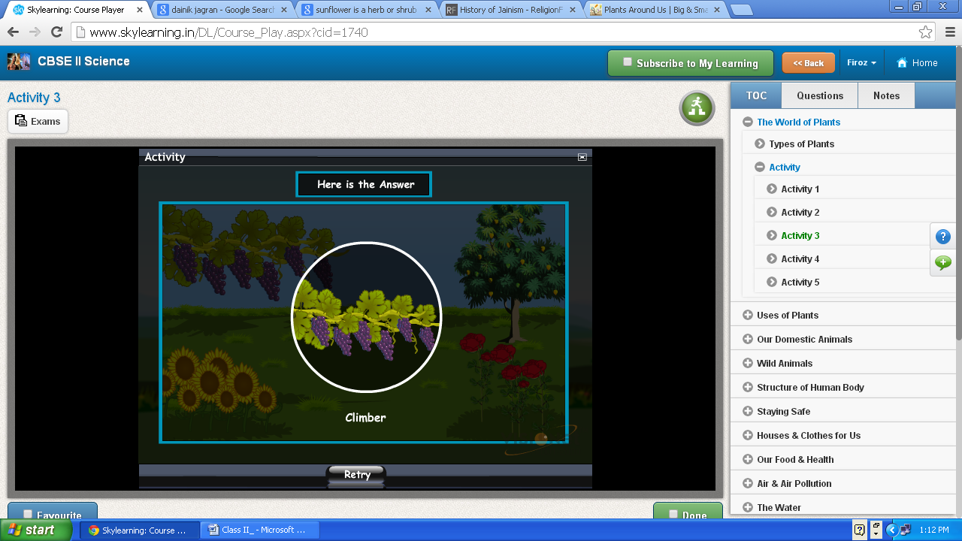
Stems of some plants are weak. They cannot stand erect on their own.
Grapevine, pea, money plant, etc., are climbers.

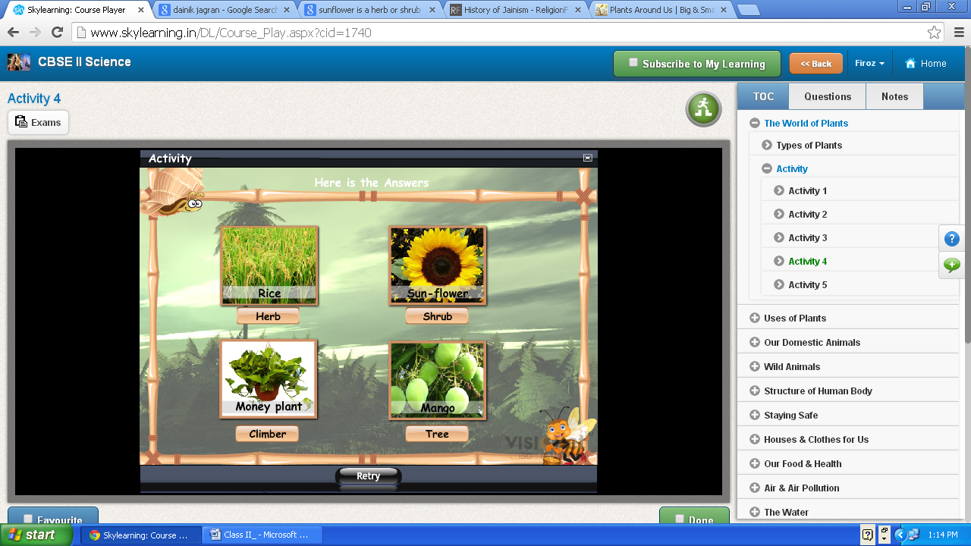

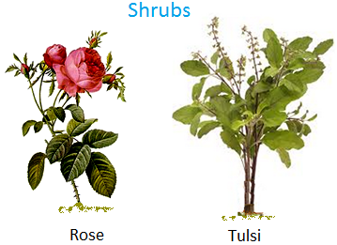

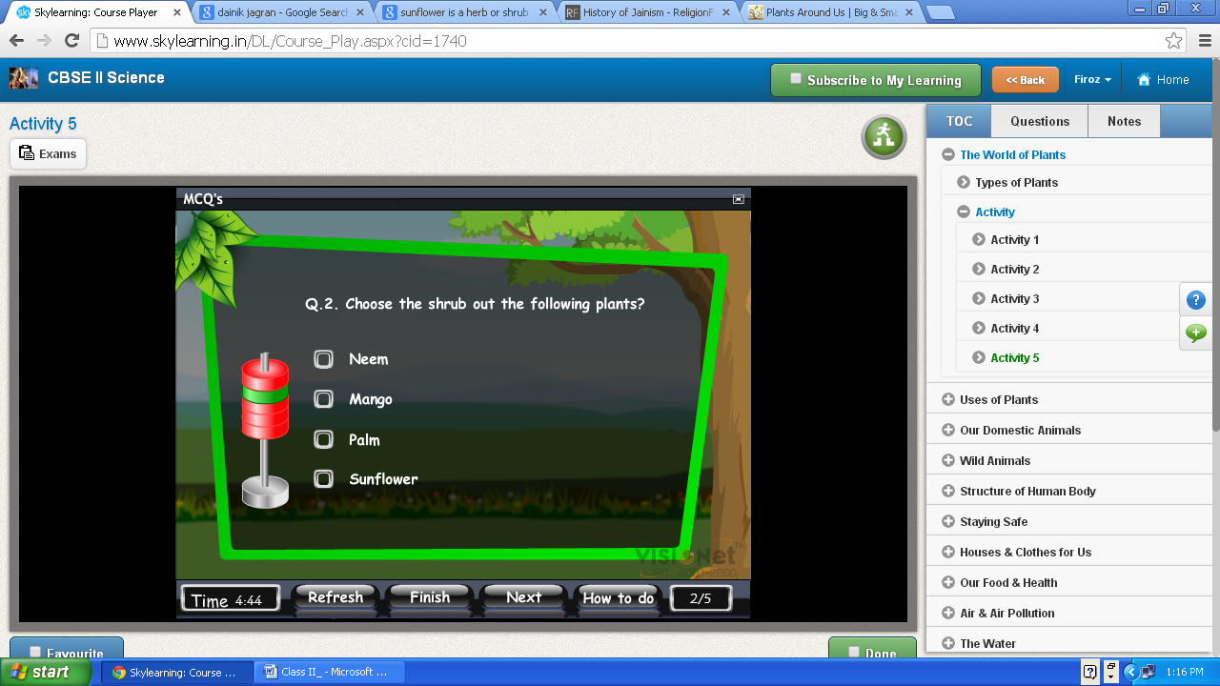
Rose

.
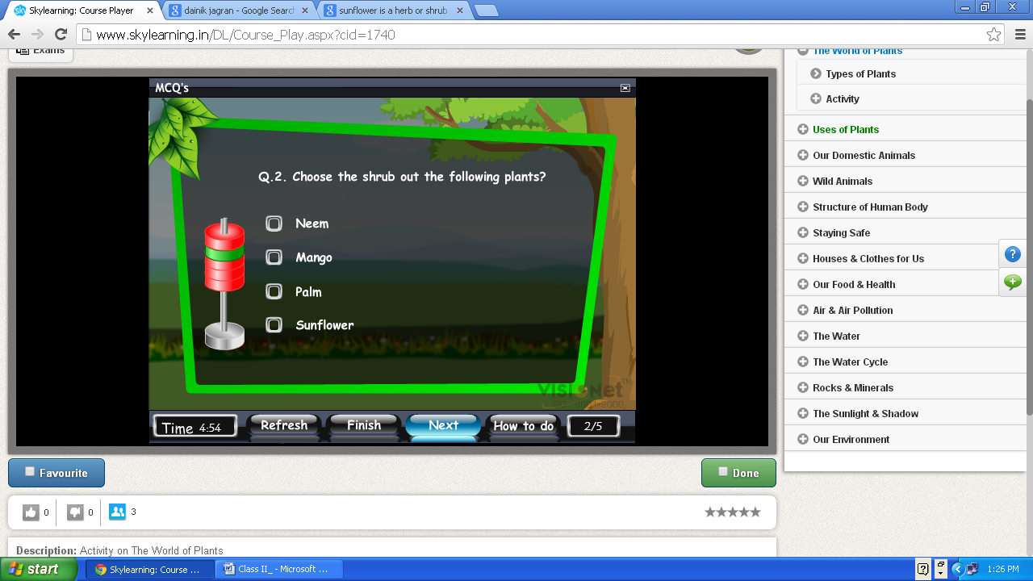
Uses of Plants
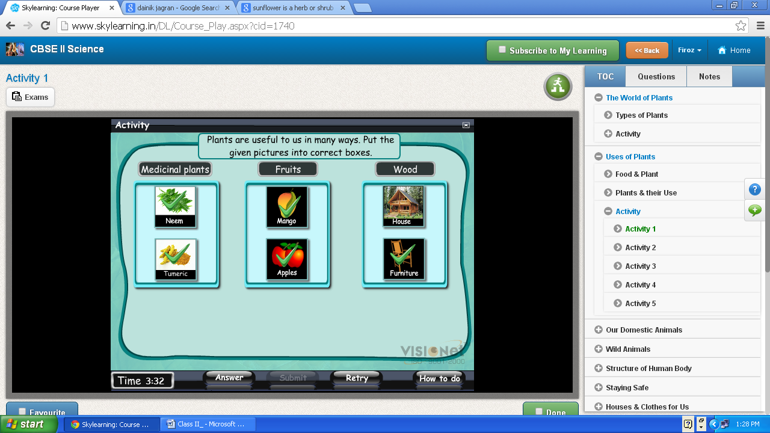
Check it –not show correct option
Our Domestic Animals
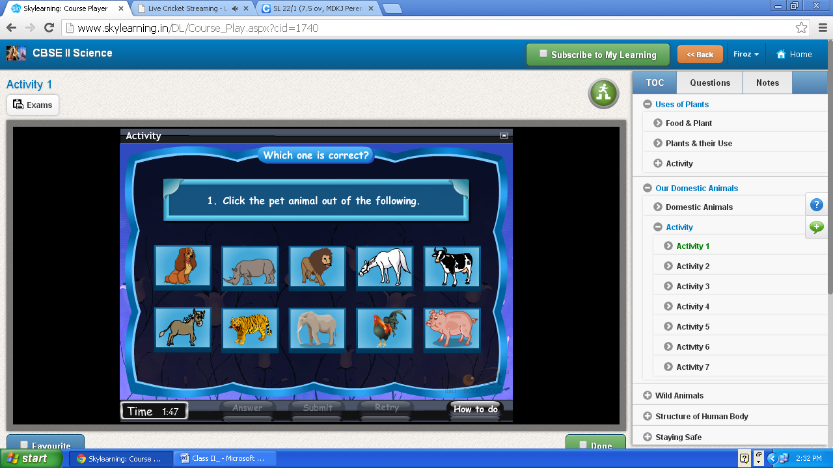
domestic
Correct answer- dog, Horse , donkey , pig
Check - correct- select only one

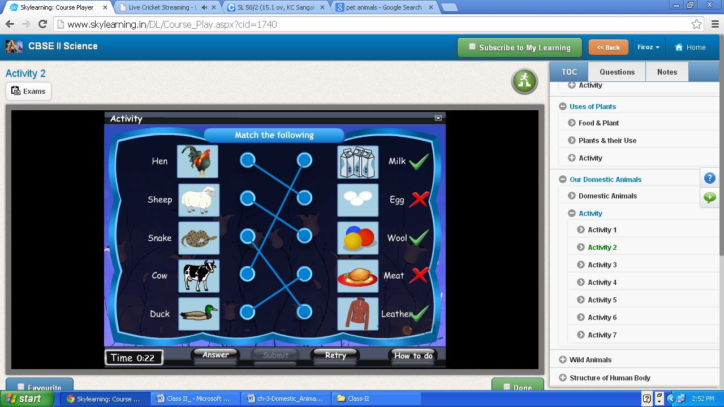
Goat –Meat
Hen –Egg

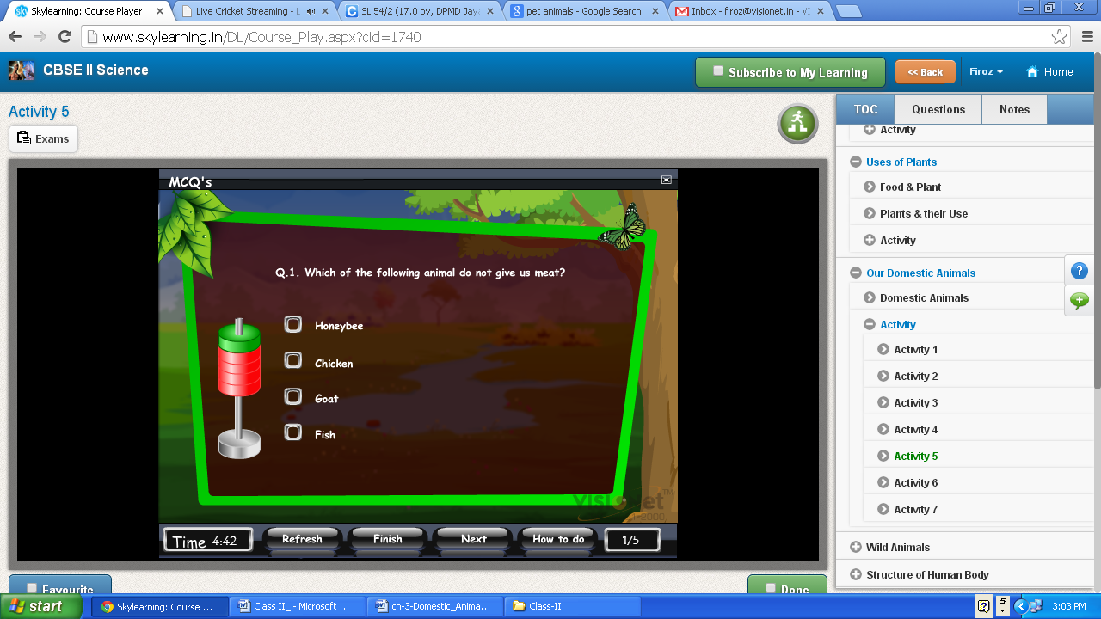
Does
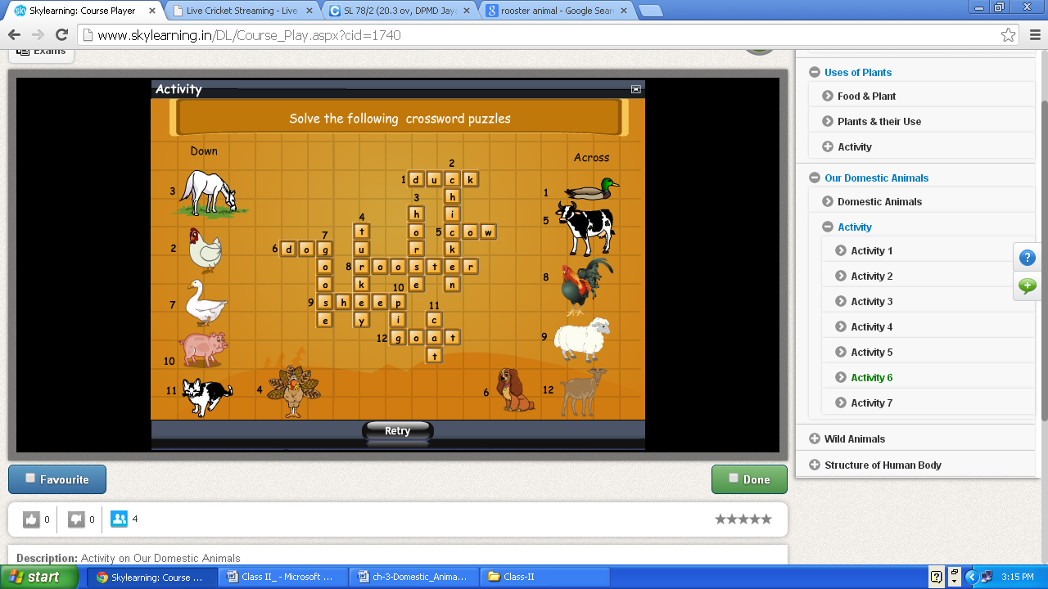
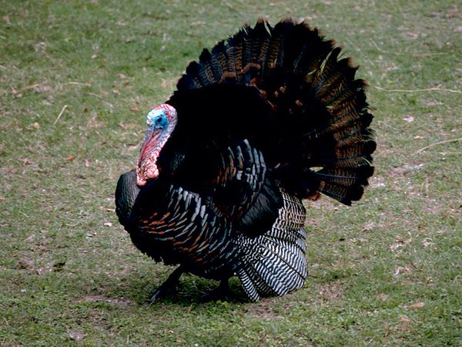

Wild Animals

Structure of Human Body
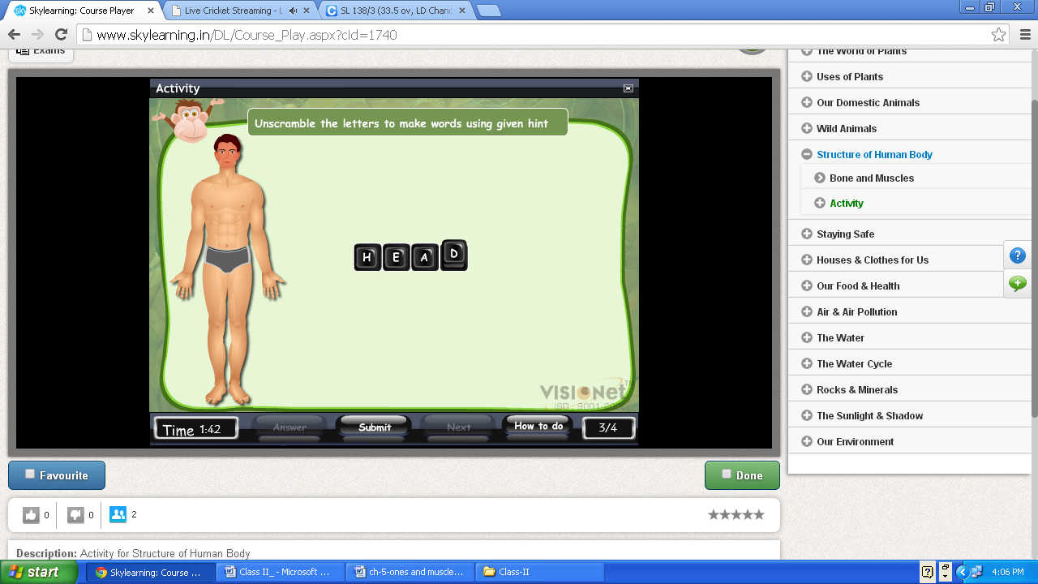
Blink the head portion not face

Staying Safe
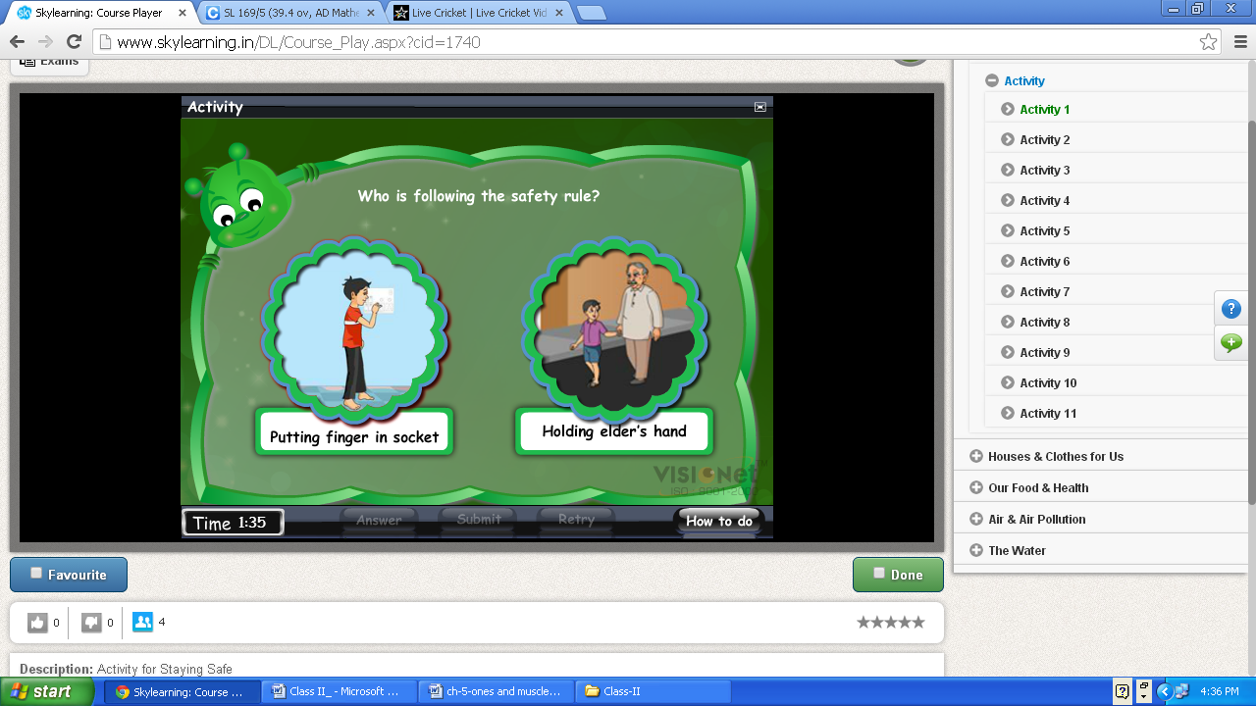
Click on correct images who follow the safety’ rule.

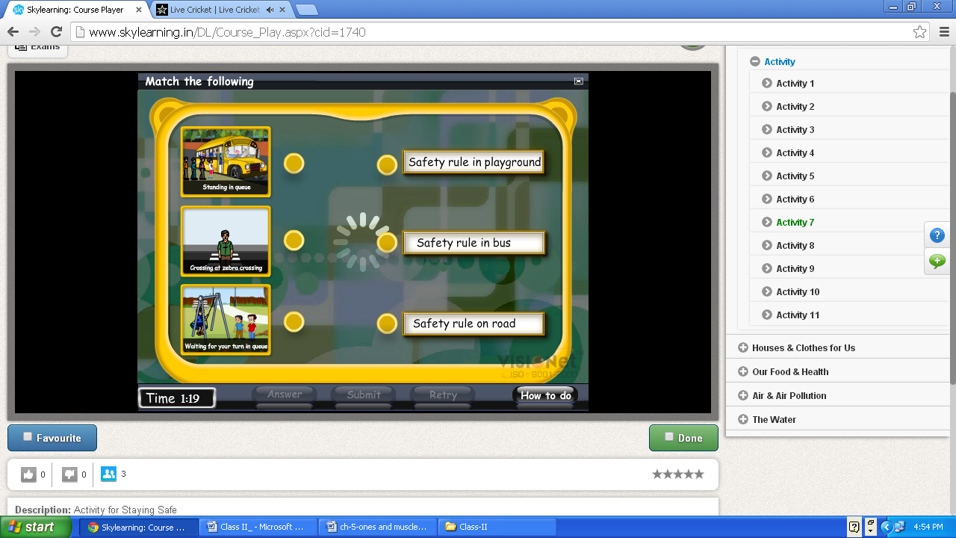
Check the loader

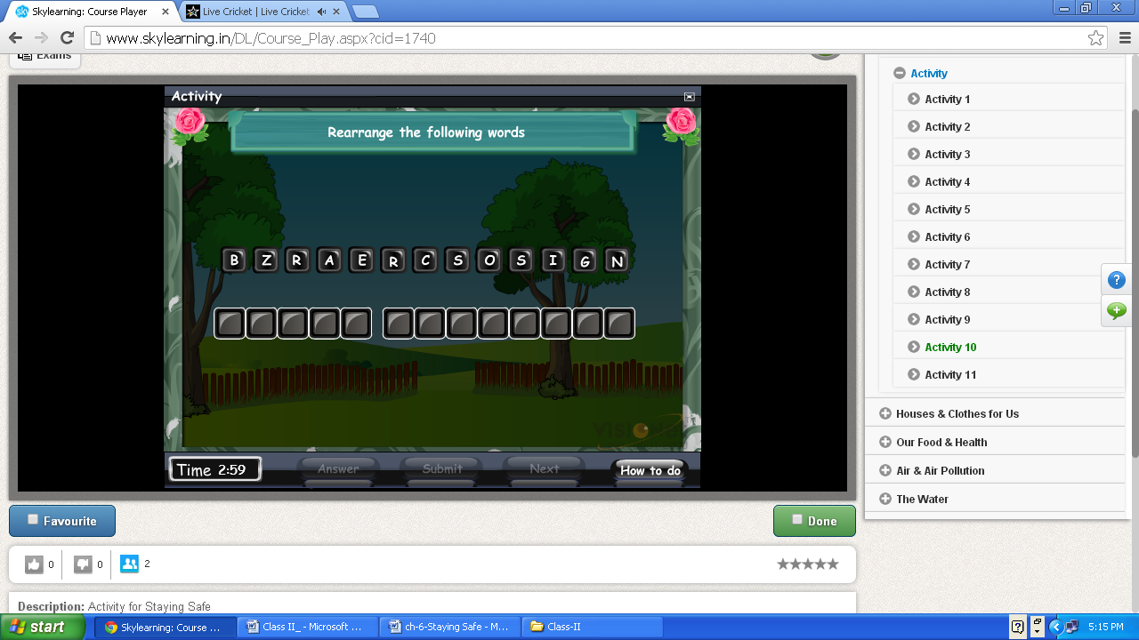
A box contains cotton, antiseptic cream,, pain killer, bandage, scissors, etc is called

3. We can ------- in water .
Add question
2.We should follow __________ while crossing road.

We should cross the road at____________

Houses & Clothes for Us
The Water

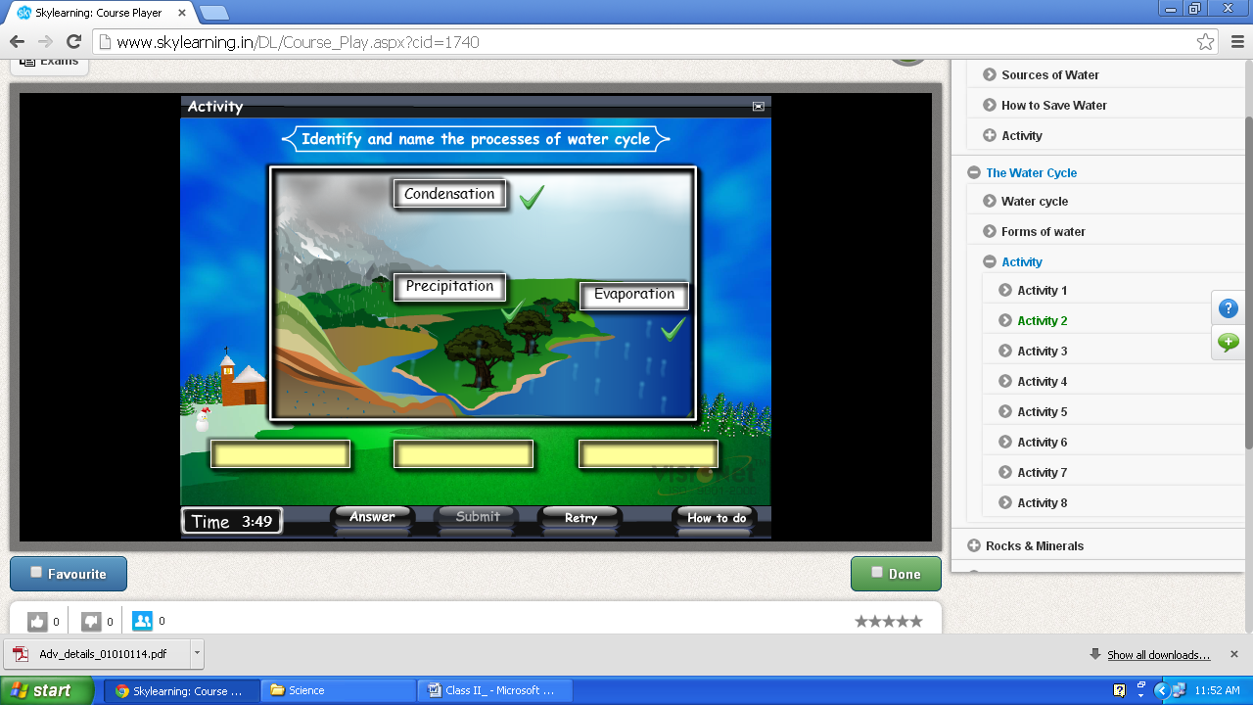

Rocks & Minerals
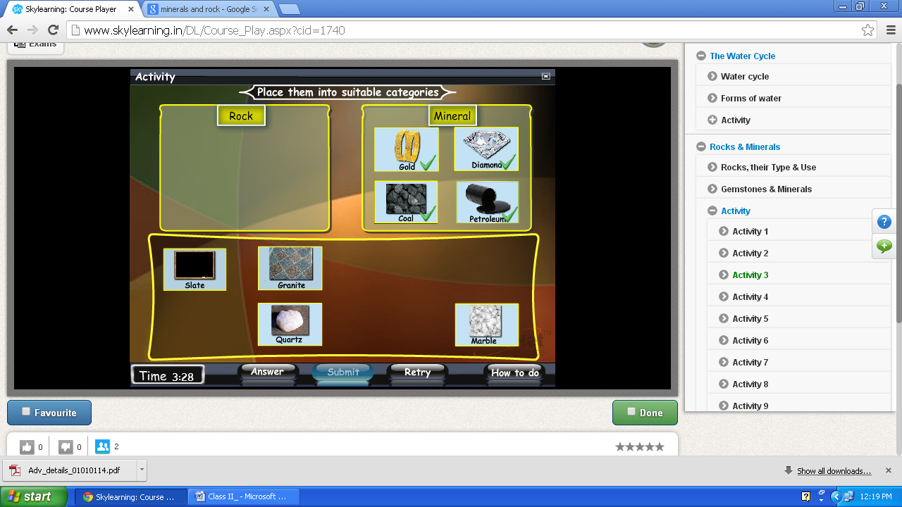
Change all option of minerals as:
Quartz , Mica, Feldspar, Gypsum

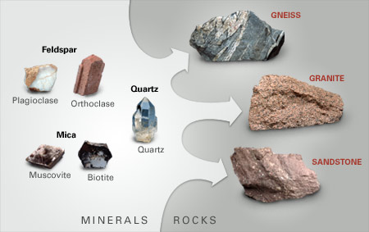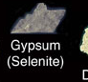

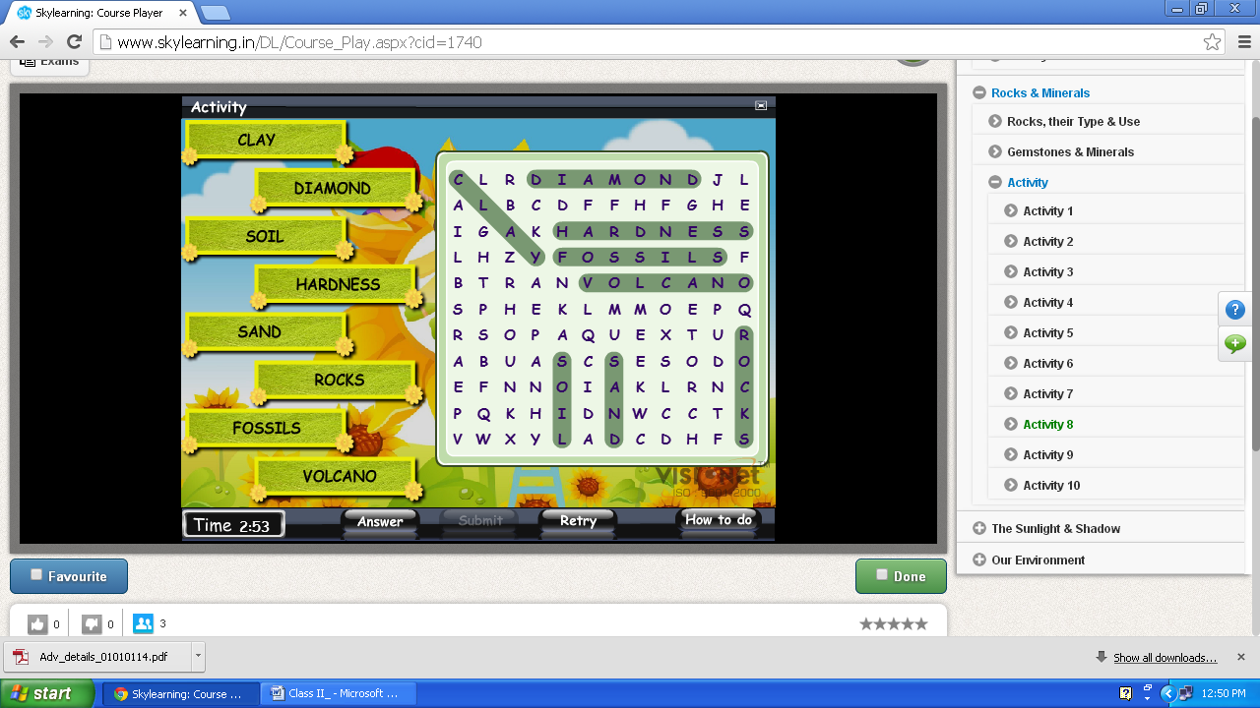
Well done

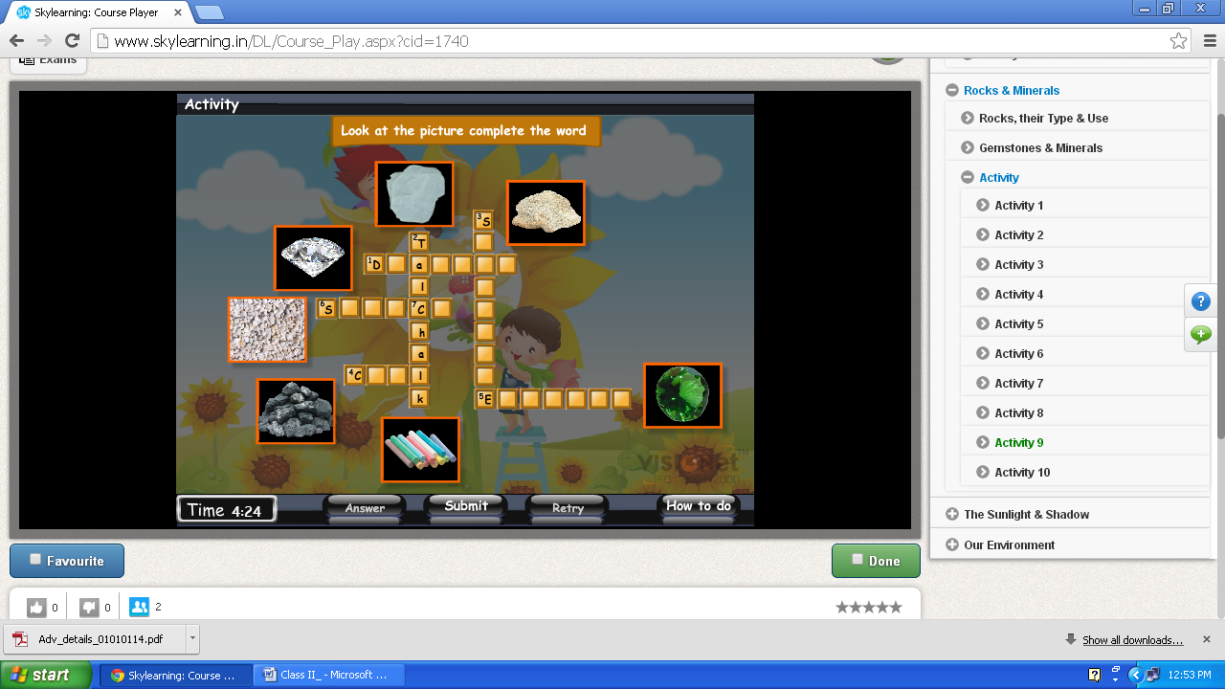
6
Delete
The Sunlight & Shadow
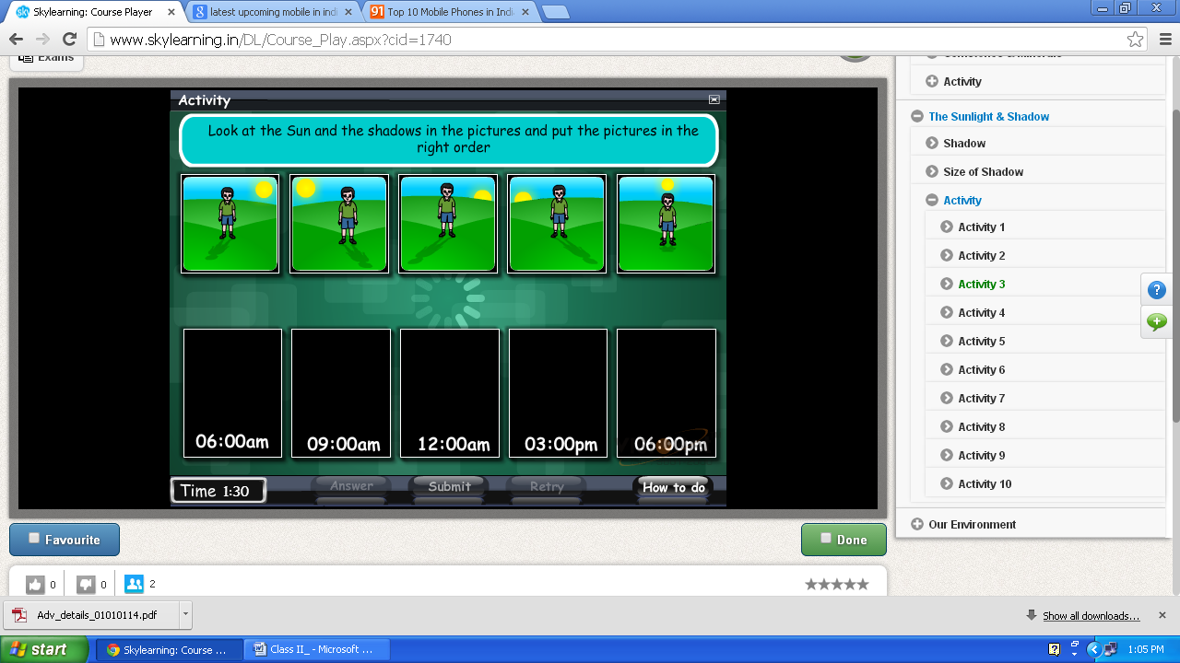
Loader

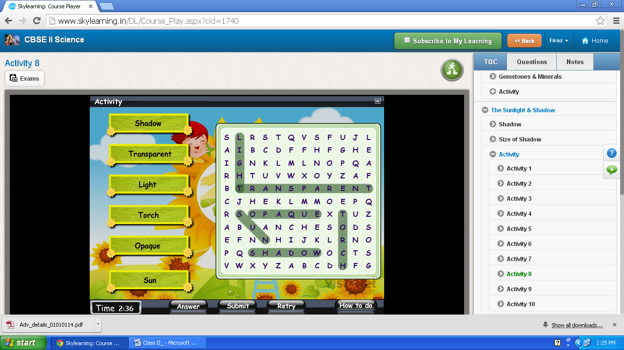
Pop-wind - Excellent
Pop-wind - Excellent
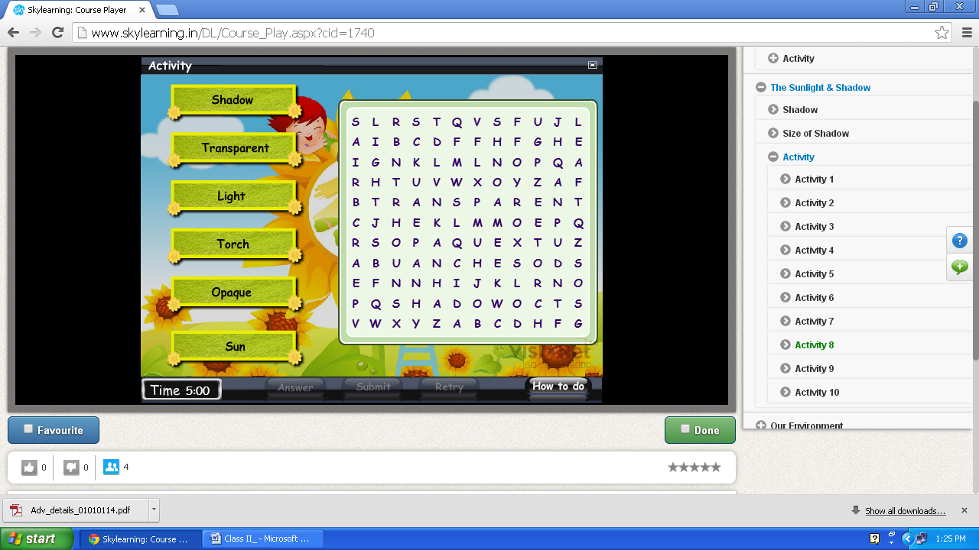

Our Environment
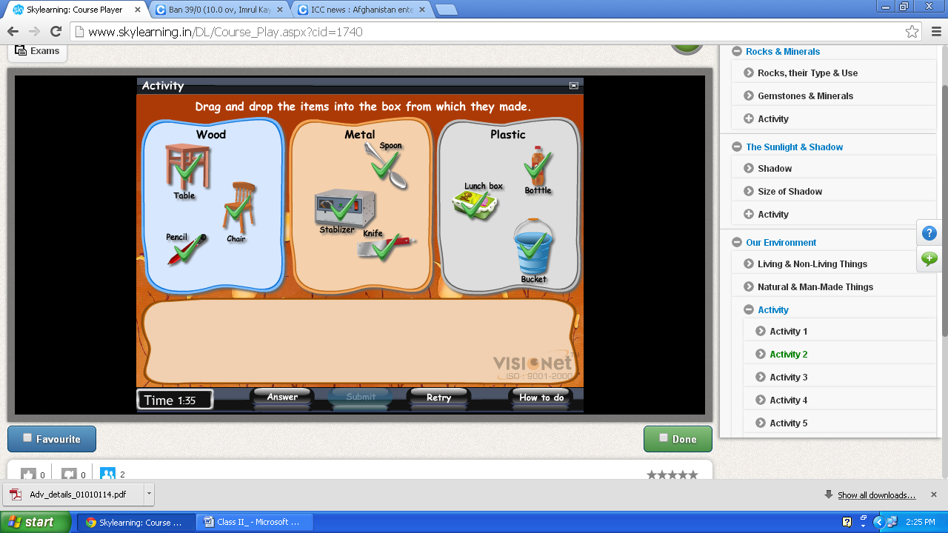
Show kinife

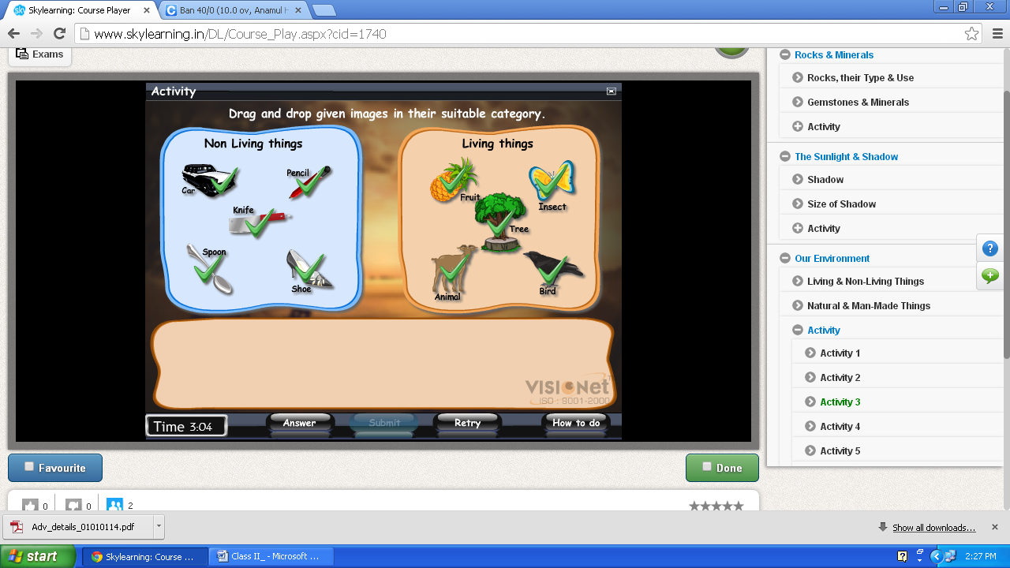
Insect –show

