**TRAVELLING IS FUN**

We use different means of transport to travel to places that are far away.

In olden times, people moved from one place to another on foot.

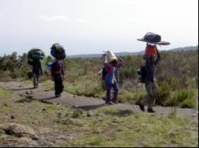

Later, animals like horse, elephant, camel and donkey were tamed. People started riding and carrying their goods on them.

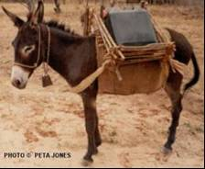

Invention of wheel helped the people to make carts. Horses and bullocks pulled the carts.

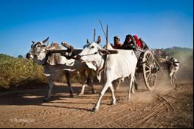

**DIFFERENT TYPES OF TRANSPORT**

* **LAND TRANSPORT:**

It is the movement of people, things and animals from one place to another on land. The different means of land transport are:

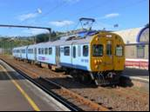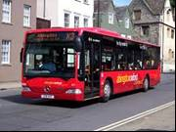

train bus

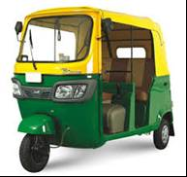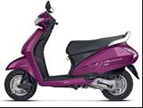

autorickshaw scooter

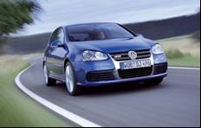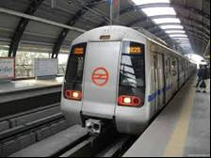

car metro

A train and a metro moves on tracks. They have many wheels and are pulled by engines.

Buses and trucks have six wheels.

* **WATER TRANSPORT:**

It is the movement of people, things and animals from one place to another through water. The different means of water transport are:

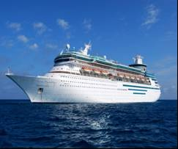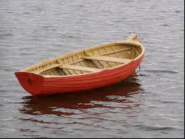

ship boat

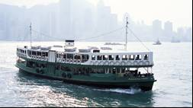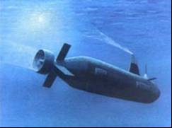

ferry submarine

* **AIR TRANSPORT:**

It is the movement of people and things from one place to another by air. The different means of air transport are:

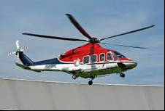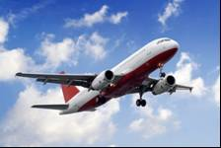

helicopter aeroplane

They move very fast.

Astronauts use rockets to go into space.

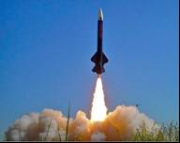

rocket