Story sums (Addition)

Word problems build higher-order thinking, critical problem-solving, and reasoning skills. It is a simple addition process. The words like more, total refers to adding of numbers.

Eg: 1. There are 3 yellow flowers and 5 red flowers in a garden. How many flowers are there in all?

[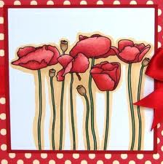](http://www.google.co.in/imgres?start=126&biw=1366&bih=587&tbm=isch&tbnid=3Atp9-hgdq4qMM:&imgrefurl=http://periscardblog.blogspot.com/2010_04_01_archive.html&docid=OQFRhw1qY1AHvM&imgurl=http://1.bp.blogspot.com/_8Rkh5EcOs1Y/S9SjyFv-Y0I/AAAAAAAAAsA/Ike6XveyA2c/s1600/Poppies%252BClose%252Bup.jpg&w=433&h=434&ei=f0fKUsbeLpCRiQffg4CYDg&zoom=1&iact=hc&vpx=772&vpy=239&dur=2171&hovh=225&hovw=224&tx=140&ty=135&page=5&tbnh=134&tbnw=133&ndsp=33&ved=1t:429,r:31,s:100,i:97)

T O

Yellow flowers : 3

Red flowers : 5

Total flowers: 8

E.g.2 There are 27 boys and 16 girls in a class. Find the total number of students.