Perimeter and Area
- The sum of all sides of a closed figure is called its perimeter.
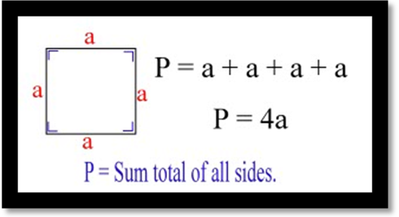
- Perimeter of a square = 4 X side
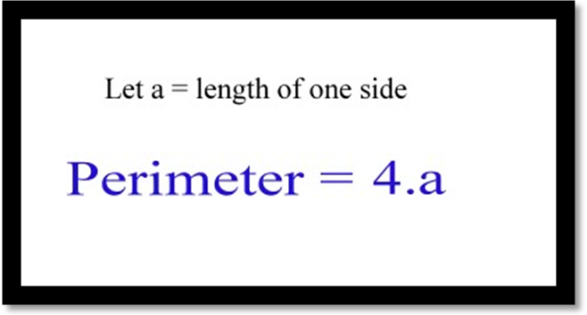
- Perimeter of a rectangle = 2 X ( Length + breadth)
- The space covered by a closed figure is called its area.
- Area of a square = Side X Side
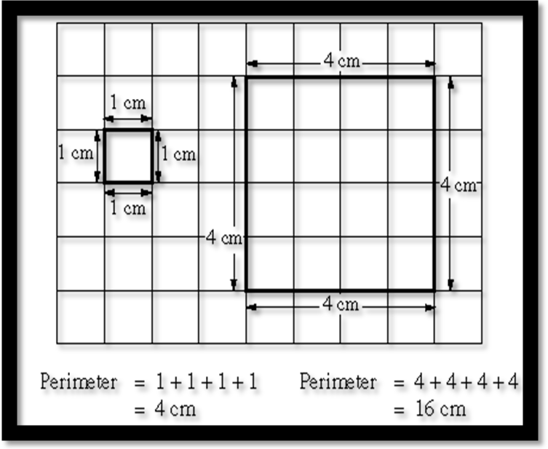
- Area of a rectangle = Length X Breadth

