**Soil**

## Introduction

**S**oil is the thin layer on top of most of the Earth’s land surface. This thin layer is a very precious natural resource. It holds nutrients and water for plants and animals. It provides the bed for plants to grow. If there were no soil, there would be no grass, no crops, no trees, no plants, and thus no nourishment for us and other terrestrial animals. We depend on soil for most of our daily needs—our food, clothing and other materials such as paper, building, etc

## What is soil?

Soil is a complex mixture of inorganic materials (clay, silt, pebbles, and sand), decaying organic matter, water, air, and billions of living organisms.

## Formation of Soil:

Soil is formed when organic matter decays, solid rock weathers and crumbles, and sediments are deposited by erosion. The formation and the properties of soil depend on various factors. The characteristics of the soil at any given point depend upon climate, living organisms, parent material, relief, and time.

## formation.gif

## Soil Profile:

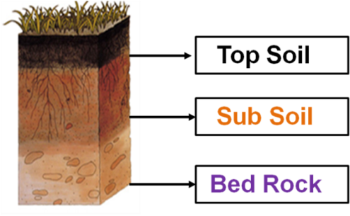Soil consists of three layers.

The topmost layer on which the plants grow is called the **Top Soil.**

Below it is the **Sub Soil** having small rocks. Only the roots of very big trees reach this layer.

At the bottom is the **Bedrock** which mainly consists of the big rocks.

## Soil Erosion:

The removal of top soil by the action of wind or water is called **soil erosion**. Soil erosion makes the earth’s surface uneven. Heavy rainfalls and wind, loss of vegetative cover, growth of weeds; etc. are some of the factors that lead to soil erosion.

## Causes of Soil Erosion:

Soil erosion is caused by various factors such as

* Wind
* Water
* Climate
* Landslides
* Deforestation

## Effect of Soil Erosion:

1. Agricultural cultivation
2. Forest Harvesting
3. Overgrazing
4. Urban Construction

## Prevention of Soil Erosion:

Soil erosion can be controlled by the following ways:

1 .By planting more trees (forestation).

2. By growing grasslands.   
3. By providing proper drainage system in the fields.   
4. By terrace cultivation on sloping fields.

5. By control of grazing.

## The different types of soils found in India:

## Indian soil has been divided into four categories:

## (i) Alluvial Soil

## (ii) Red Soil

## (iii) Black Soil

## (iv) Laterite Soil.

**Alluvial Soil:** The fertility of the alluvial soil varies from place to place. Due to its softness and fertility, alluvial soil is most suited to irrigation and can produce bumper crops of rice, wheat, maize, sugar cane, tobacco, cotton, jute, oilseeds, etc. It is found in Punjab, U.P., Bihar and West Bengal.

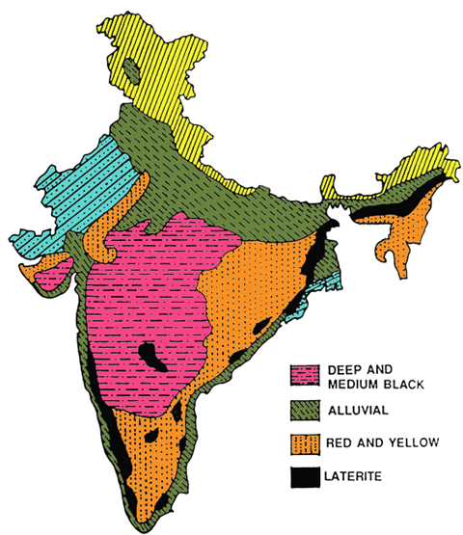**Red Soil:** **i)** M**ost of the red soil has been formed due to weathering of igneous and metamorphic rocks.**

**ii). The red colour is due to the high percentage of iron contents.** It is found in Tamil Nadu, Mysore, some portions of West Bengal, U.P. and half of Rajasthan.

**Black Soil:** Due to high fertility and capacity to hold moisture, black soil is widely used for producing cotton, wheat, linseed, millets, tobacco and oilseeds. With proper irrigation facilities, this soil can also produce rice and sugar cane. It covers Madhya Pradesh, Maharashtra and Andhra. Cotton, wheat, linseed and gram are grown in this soil.

**Laterite Soil:** Due to intensive leaching, the laterite soil generally lacks fertility and is of low value for crop production. But when manured and timely irrigated, the soil is suitable for producing plantation crops like tea, coffee, rubber, coconut, etc. It is found in Madhya Pradesh and Assam etc.