**Make your own Magnet- Magnetization**

Magnetization is the process by which a magnetic substance attains magnetism temporary or permanent.

The methods used to magnetize a magnetic substance are –

* single touch method
* double touch method
* Electrical method of magnetization

Take a bar magnet and an iron bar. Now rub the bar magnet 30-40 times over the iron bar. Bring the iron bar near the needle clips. **Observation:** You will see that iron bar attracts the needle clips.

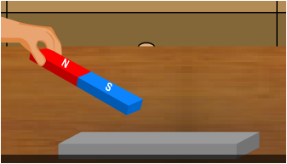 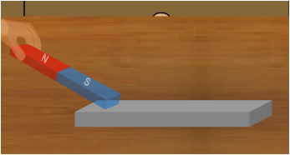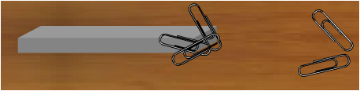

**Demagnetization**

Demagnetization is the process of removing the magnetic property of a magnet.

A magnet looses its magnetic properties when heated, hammered or dropped by height.