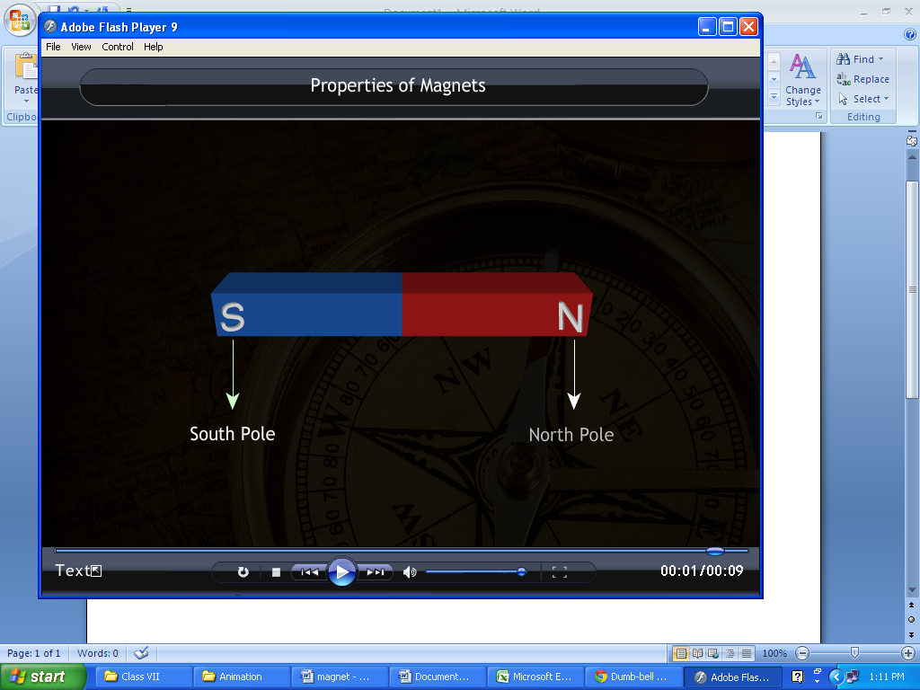**Properties of a Magnet**

* Substances that possess the property of attracting iron are called magnets.
* The two ends of a magnet are called its poles.
* All magnets have two poles, and they are called dipoles.
* A magnet with a single pole doesn't exist. Since poles have high magnetic power, they attract objects easily.
* The poles of a magnet are named as the North Pole and the South Pole. In order to identify the poles, the North Pole is usually painted in red colour. The other end of the magnet will, therefore, be the South Pole.
* In laboratories, magnets are painted completely red in colour with a white dot to indicate the North Pole. The other end will, therefore, be the South Pole.
* A magnet can be cut into two pieces. Each piece will behave like an independent magnet, with a north pole and a south pole.

**Finding directions**

* In the ancient days, an old pointing device was called the south pointing fish. It was used to know the directions. The head of the fish pointed towards the south.
* A compass is an instrument that is used to find the directions. It has a thin magnetic needle supported from a pivot so that it can rotate freely. The needle is placed over a dial with the directions marked. The entire assembly is placed inside an airtight box. The north pole of the magnetic needle is painted red. The magnetic needle in the compass points in the north-south direction. By aligning the dial properly, the directions can be found.

**Activity**

Take a bar magnet having labels of North and South Poles. Take a thread and tie it in the middle of the magnet. Now suspend it freely from a laboratory stand. You will find that the magnet rests in that particular direction only as shown in figure. **Observation:** The line along which the Magnet rests is called North-South Line. It is because North Pole of Magnet points towards the North direction and South pole points towards the south Direction. Line drawn perpendicular to North-south line shows East to the right & West to the left of North-South Line.

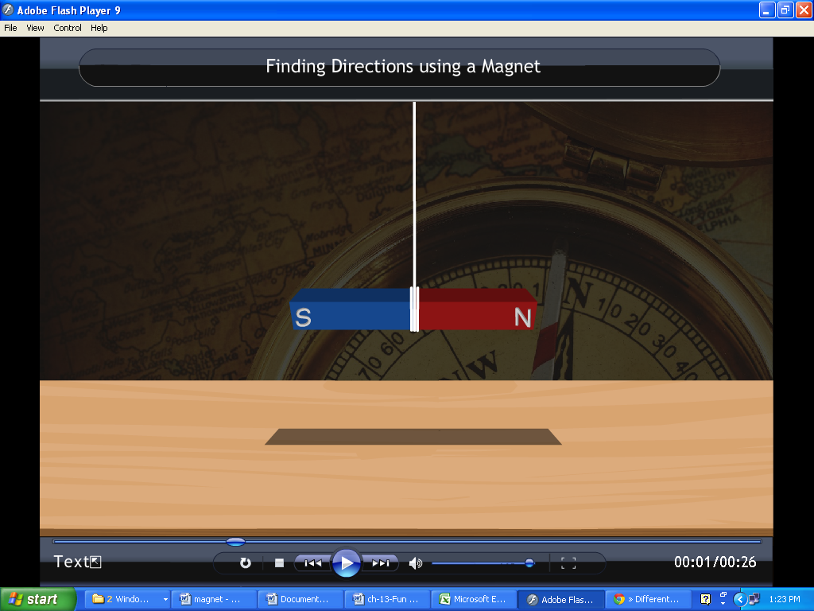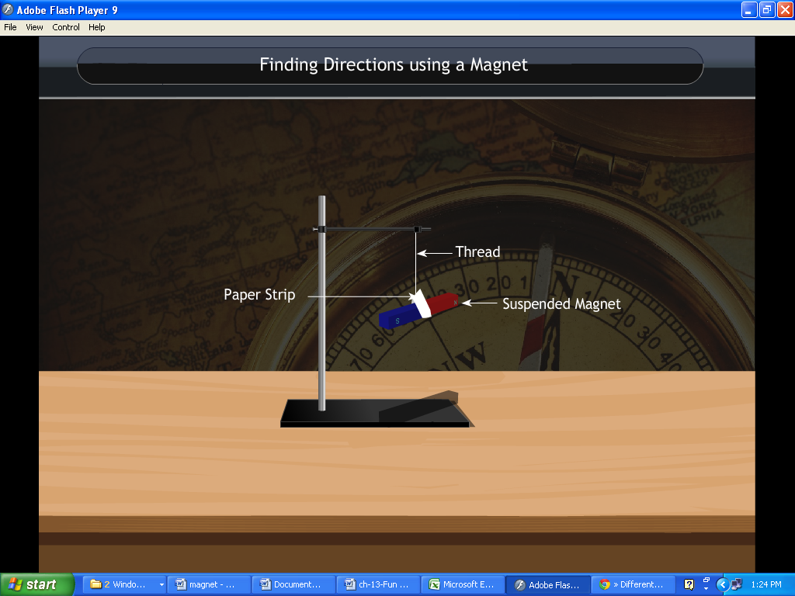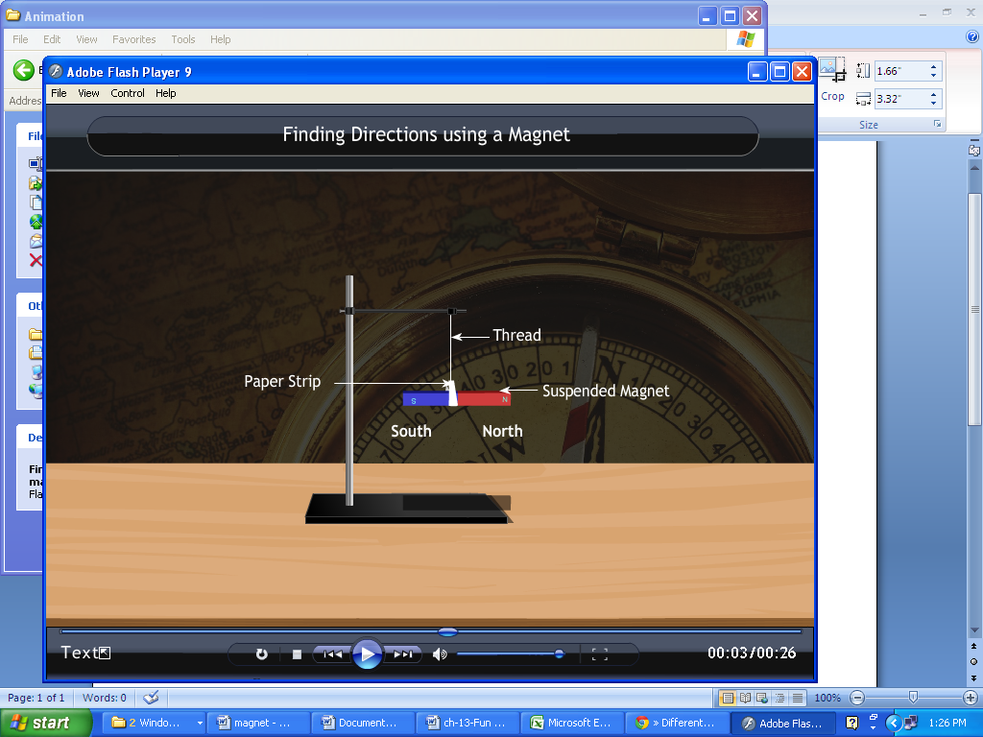

**Make your own Magnet- Magnetization**

Magnetization is the process by which a magnetic substance attains magnetism temporary or permanent.

The methods used to magnetize a magnetic substance are –

* single touch method
* double touch method
* Electrical method of magnetization

**Demagnetization**

Demagnetization is the process of removing the magnetic property of a magnet.

A magnet looses its magnetic properties when heated, hammered or dropped by height.

Activity

Take a bar magnet and an iron bar. Now rub the bar magnet 30-40 times over the iron bar. Bring the iron bar near the needle clips. **Observation:** You will see that iron bar attracts the needle clips.

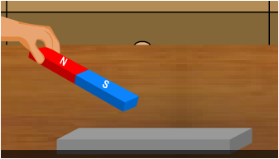 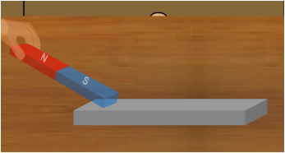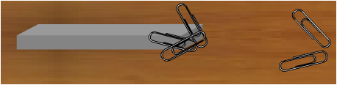

**Attraction and Repulsion**

The poles of two magnets that are different or opposite will attract. Magnetic lines of force from north and south poles pull together and join. The poles of two magnets that are the same will repel or push each other apart.

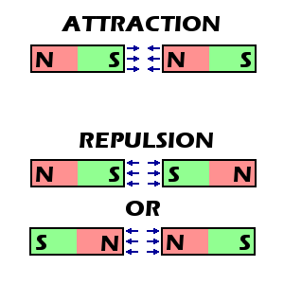 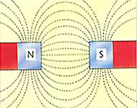

**Law of magnets**

Unlike poles attract each other and like poles repel each other.

****************************************