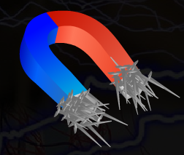
Magnetic and Non-magnetic Materials
Magnetic Materials
- Materials that are attracted by a magnet are called magnetic materials.
- Objects made of materials such as iron; cobalt and nickel are magnetic objects.
- Examples of magnetic materials include iron nail, key, metal spade, needle and metal door handle.
Non-Magnetic Materials
- Materials that are not attracted by magnets are called non-magnetic materials.
- Modern coins are made of uniform mixtures of different metals so they become non- magnetic.
- Examples of non-magnetic materials include rubber, coins, feather and leather.
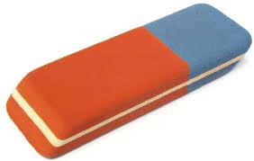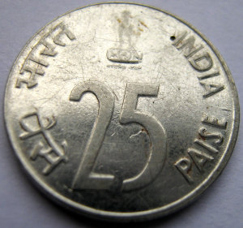
Coin
Rubber
Types of magnets
Bar magnets: In these magnets, the poles are located at the ends of the bar.
Cylindrical magnets: In these magnets, the poles are located at the two circular ends of the cylinder.
Horseshoe magnets: In these magnets, the poles are located at the two free ends of the 'U' shape.
Dumb-bell shaped magnets: In such magnets, the poles are located at the two dumb-bell shaped ends.
