Fun with Magnets

How Magnets were discovered?
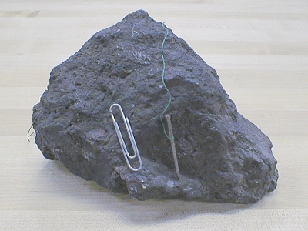
A Greek shepherd named Magnes discovered magnets 4,000 years ago in Magnesia, Greece. The name magnetite has been derived from Magnesia or Magnes. Magnets are named after Magnetite.
Magnets attract magnetic materials. Natural rocks that have the property of attracting iron are called naturals magnets. Magnes discovered a natural magnetic rock, called the lodestone. In the form of a bar, it was used to find directions on the earth, and so the name, ‘lodestone,’ which means the stone that leads. Lodestone has a compound of iron called magnetite. These natural magnets have the magnetic property of attracting materials like iron.
Lodestone

Artificial magnets
Magnets can be made by man is called artificially magnets. A rectangular iron bar, an iron needle, a blade or an iron nail can be turned into a magnet by rubbing a bar magnet over it.

