Component of Food
Deficiency diseases
Diseases occurring due to lack of nutrients over a long period of time are called Deficiency diseases. For e.g. lack of iodine in diet causes goiter.
Protein deficiency- If a person does not get enough proteins in his/her food for a long time, he/she is likely to have stunted growth, swelling of face, discolouration of hair, skin diseases and diarrhoea. Marasmus and Kwashiorkor are protein deficiency diseases.

Below is a table discussing the deficiency diseases with their symptoms.

Vitamin/  Mineral | Deficiency  disease/ disorder | Symptoms | Image
Vitamin A | Poor vision | The vision is lost in dark or may get lost completely. | 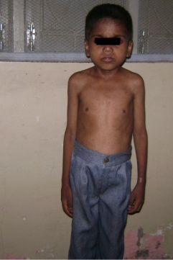
Vitamin  B1 | Beriberi | The muscles become weak and hence very less energy is left to do work. | 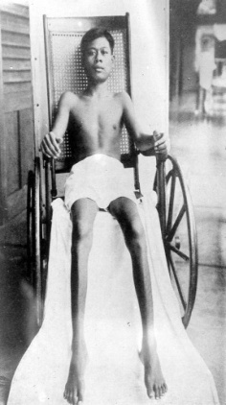
Vitamin C | Scurvy | The gums become weak and bleed. | 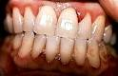
Vitamin D | Rickets | The bones get affected. They become soft and twisted. | 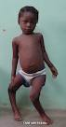
Calcium | Bone and tooth  Decay | Leads to tooth decay.
Iodine | Goiter | The gland in the neck region swells. | 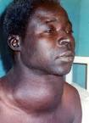
Iron | Anaemia | The blood lacks iron and there is weakness in the whole body. | 