Food: Where Does It Come From?

Animals Products as Food

Animal’s products are: Egg, Butter, Fish, Curd milk, meat, chicken etc.

Plant Parts Products As Food

It is surprising to know that we eat different parts of the plant in different food variety. For instance take the example of cabbage, a green leafly vegetable that most kids dislike to eat. It is the leaf of the plant that we eat.

Below is a table discussing the edible parts of various plants.

Leaves  The leaves of spinach are eaten. Other e.g. are mustard and fenugreek. | 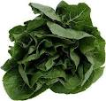  Spinach
Roots  Carrot, radish and beetroot are the roots. | 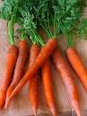  Carrot
Flower  Flower of banana and pumpkin are the edible parts. | 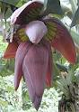  Banana
Stem  The sugarcane that is used to make sugar is the stem of the plant. Potato is also an underground stem called tuber. | 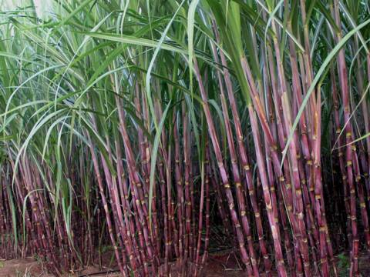  Sugarcane
Seeds  The seeds of mustard are used for making vegetable oil. Other e.g. is soyabean. Black pepper is a seed used as a spice. | 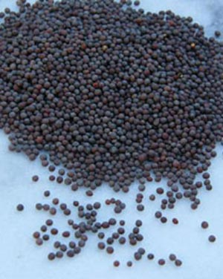  Mustard seeds
Fruit  Apple , banana and mango are all eaten as fruit. | 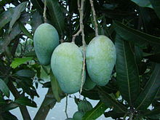  Mango

